**Final Project**

**Date due: April 19, 2019**

**Project name:** Stock Market/ Market Edge

**Absolute URL** (to home page): localhost/project-eagles/

**Log-in details:** Username:- [user@eagles.com](mailto:user@eagles.com)

Password:- user@eagles.com

|  |
| --- |
| **Instructions on how to hand in assignments** |
| **MANDATORY RULES**    **1.** Hand in project through Blackboard **on time**.  **2.** Only the Team Leader is to submit the project web site through Blackboard.  **3.** If assignment is handed in late, then late penalties will apply. |
| **Assignment Documentation**  **1.** Upload to blackboard all the files, cover pages, and browser documentation  **2.** This documentation (including the peer evaluations) is to be submitted to the instructor  **3.** By submitting this documentation, you agree that all work is your own.  **4.** Assignments will not be returned back but kept for reference of student progress.  (Therefore, keep your own copies of all work handed in) |
| **Late Hand In penalties:**  *Note: ‘Days Late’ are calendar days. This includes weekends, holidays, and all other days.  Subtract 15 % off of mark received - 1 day (up to 24 hours exactly) after due date.  Subtract 30 % off of mark received - 2 days (up to 48 hours exactly) after due date.  Subtract 45 % off of mark received - 3 days (up to 72 hours exactly) after due date.  *** A zero grade will be received if assignment is handed in later than 3 days  (Later than 72 hours exactly) after due date. |
| **Due Dates and Penalties will be re-assessed with any of the following conditions:**  1. Students who are ill and have a physician's letter. This letter must indicate that the student was incapacitated for 1 week prior to the due date of the assignment, in other words, the student could not work for 1 week prior to the due date, from the beginning date that the assignment was assigned. It is assumed that assignments are not done just before the project is due but throughout the previous week. The College will call the physician to confirm the doctor's document. Therefore, please provide the physician's contact details with the physician's letter. If the student has missed many projects, and the marks indicate a failure, and the semester is over, then the student will be asked to repeat the course during the following school year due to limitations of semester time periods at the College.  2. Students who have a death in the family, and can confirm this with proper documentation. This death could be that of a family member or a family pet. The student will be granted a reasonable time to take care of family matters after which the assignment will be required. The College will call the appropriate institutions to confirm this documentation. If the student has missed many assignments, and the marks indicate a failure, and the semester is over, then the student will be asked to repeat the course during the following school year due to limitations of semester time periods at the College.  3. If the student has a family member who is seriously ill, and the student needs to spend time with this family member, then we will need appropriate documentation from the doctor tending the family member. The College will call the physician to confirm this document. Therefore, please provide the physician's contact details with the physician's letter. If the student has missed many assignments, and the marks indicate a failure, and the semester is over, then the student will be asked to repeat the course during the following school year due to limitations of semester time periods at the College. |

***Add/remove and complete the following chart for every team member.

|  |  |
| --- | --- |
| **Team Leader - *Required Information** | |
| Name: | **Yash Gandhi** |
| Student Number: | **N01293906** |
| Email: | **yashg9211@gmail.com** |
| Signature:    ***Assignment will not be marked without the student's signature.  ***digital signatures. |  |
| Files “Designed” in this project by this team member (including specific image file names, etc.). | Files Developed in this project by this team member. |
|  | **css/blog.css** |
|  | **includes/blogs/bloglistAdmin.php** |
|  | **includes/blogs/blogs.php** |
|  | **includes/blogs/create.php** |
|  | **includes/blogs/details.php** |
|  | **includes/blogs/edit.php** |
|  | **includes/watchlist/addWatchlist.php** |
|  | **includes/watchlist/deleteWatchlist.php** |
|  | **includes/watchlist/listWatchlist.php** |
|  | **includes/watchlist/addWatchlistSetting.php** |
|  | **includes/watchlist/watchlistView.php** |
|  | **models/blogs/blog.php** |
|  | **models/comments/comments.php** |
|  | **models/watchlist/watchlist.php** |
|  | **models/APIRequest.php ( only the part of my feature)** |
|  |  |

|  |  |
| --- | --- |
| **Team Member - *Required Information** | |
| Name: | **ENRINA WILMS** |
| Student Number: | **N01330654** |
| Email: | **rhylle28admz@gmail.com** |
| Signature:    ***Assignment will not be marked without the student's signature.  ***No digital signatures. |  |
| Files “Designed” in this project by this team member (including specific image file names, etc.). | Files Developed in this project by this team member. |
| **logo.png** | **includes/gainersLosers/gainersLosers.php** |
|  | **includes/news/news.php** |
|  | **includes/status/statusAdd.php** |
|  | **includes/status/statusList.php** |
|  | **includes/status/updateStatus.php** |
|  | **models/gainersLosers/gainers-loser.php** |
|  | **models/news/news.php** |
|  | **models/status/userStatus.php** |
|  | **includes/header_admin.php** |
|  | **includes/footer.php** |

|  |  |
| --- | --- |
| **Team Member - *Required Information** | |
| Name: | **Lawrence Tillson** |
| Student Number: | **N01288606** |
| Email: | **ltillson7@gmail.com** |
| Signature:    ***Assignment will not be marked without the student's signature.  ***No digital signatures. |  |
| Files “Designed” in this project by this team member (including specific image file names, etc.). | Files Developed in this project by this team member. |
|  | **includes/events/eventimages/defaultimage.png** |
|  | **includes/events/addEvent.php** |
|  | **includes/events/deleteEvent.php** |
|  | **includes/events/events.php** |
|  | **includes/events/eventsAdmin.php** |
|  | **includes/events/listEvent.php** |
|  | **includes/events/listEventClient.php** |
|  | **includes/events/updateEvent.php** |
|  | **models/events/event_class.php** |
|  | **models/faq/FAQ_class.php** |
|  | **Validation/validation.php** |
|  | **css/style.css (only the parts that apply to my features)** |
|  | **includes/faq/addFAQ.php** |
|  | **includes/faq/approveFAQ.php** |
|  | **includes/faq/DeleteFAQ.php** |
|  | **includes/faq/faq.php** |
|  | **includes/faq/faqAdmin.php** |
|  | **includes/faq/ListFAQ.php** |
|  | **includes/faq/ListFAQapproved.php** |
|  | **includes/faq/UpdateFAQ.php** |
|  | **includes/APIDividend/Dividend.php** |
|  | **includes/APIDividend/DividendAPIRequest.php** |
|  | **includes/APIDividend/DividendListPortfolio.php** |

|  |  |
| --- | --- |
| **Team Member - *Required Information** | |
| Name: | **Olga Neyezhsal** |
| Student Number: | **N01250297** |
| Email: | **neezhsal12@gmail.com** |
| Signature:    ***Assignment will not be marked without the student's signature.  ***No digital signatures. |  |
| Files “Designed” in this project by this team member (including specific image file names, etc.). | Files Developed in this project by this team member. |
|  | **includes/contact Us/index.php** |
|  | **include/contact Us/messages.php** |
|  | **includes/contactUs/delete.php** |
|  | **includes/contact Us/details.php** |
|  | **includes/contact Us/ customerror.php** |
|  | **models/contact.php** |
|  | **css/main2.css** |
|  | **includes/loginRegistration/index.php** |
|  | **includes/loginRegistration/login.php** |
|  | **includes/loginRegistration/login_admin.php** |
|  | **includes/loginRegistration/logout.php** |
|  | **includes/loginRegistration/session.php** |
|  | **includes/loginRegistration/secure.php** |
|  | **includes/loginRegistration/users.php** |
|  | **includes/loginRegistration/register.php** |
|  | **includes/loginRegistration/profile.php** |
|  | **includes/loginRegistration/delete.php** |
|  | **includes/loginRegistration/usererror.php** |
|  | **models/user.php** |
|  | **css/login.css** |
|  | **css/style_admin.css** |
|  | **includes/IPO/ipo.php** |
|  | **models/IPO/gainers_ipo.php** |

|  |  |
| --- | --- |
| **Team Member - *Required Information** | |
| Name: | **Kenneth Mendoza** |
| Student Number: | **N00598007** |
| Email: | **kenneth.b.mendoza@gmail.com** |
| Signature:    ***Assignment will not be marked without the student's signature.  ***No digital signatures. |  |
| Files “Designed” in this project by this team member (including specific image file names, etc.). | Files Developed in this project by this team member. |
|  | **includes/portfolio/addPortfolio.php** |
|  | **includes/portfolio/deletePortfolio.php** |
|  | **includes/portfolio/editPortfolio.php** |
|  | **includes/portfolio/editPortfolioView.php** |
|  | **includes/portfolio/listPortfolio.php** |
|  | **includes/portfolio/listPortfolioSetting.php** |
|  | **includes/portfolio/portfolioView.php** |
|  | **includes/chart/chartView.php** |
|  | **includes/search/search_result.php** |
|  | **includes/search/tickerInfo.php** |
|  | **models/portfolio/portfolio.php** |
|  | **models/chart/displayChart.php** |
|  | **models/APIRequest.php** |
|  | **css/style.css** |
|  | **js/portfolio.js** |

***NOTE: This is a group mark.

|  |  |  |  |
| --- | --- | --- | --- |
| **Mark:** | **/12** | **/8** | **/20** |
| **Description:** | **User Interface**  · Professional, clean and marketable **(2)**  § Easy to read content  § Complimentary colors  § Simple, clean design  · Easy to navigate / Usability **(2)**  § Easy to understand navigation  § Easy to locate anything  § Understandable page flow  · Consistent layout **(2)**/ Cross-browser compatible **(2)**  § Use template for all pages  · Relevant content/images (not lorem ipsum) **(2)**  · Responsive **(2)**  § Tablet, mobile, desktop | **Database design**  · Proper naming conventions for tables and columns **(3)**  § Consistency (with naming-uppercase lowercase)  § Meaningful table and column names  · Normalize/optimize table **(3)**  · Table relationship (primary/foreign key) **(2)** | **Total (for overall web site)** |

**Developer’s Name: Yash Gandhi**

|  |  |  |  |  |
| --- | --- | --- | --- | --- |
| **Feature #1**  **Blogs** | URL:- 1) For Public side  [http://localhost/project-eagles/includes/blogs/blogs.php](http://localhost:8080/project-eagles/includes/blogs/blogs.php)  2) For the Admin side  [http://localhost/project-eagles/includes/blogs/bloglistAdmin.php](http://localhost:8080/project-eagles/includes/blogs/bloglistAdmin.php)  Description:  This feature only allows the registered users to view the blog posts. In this feature, admin can control the blog section of their website by allowing them to create, edit and delete blogs. The registered users can post comments on blog posts. Admin has total control over which comments should be displayed. Admin can see all the comments posted for particular blog post by details view of the blog. Admin can delete comments from details view of the blog. Each input is taken from the user side goes through the sanitization process before being stored in the database. | | | |
| /15 | /5 | /5 | TOTAL /25 |

|  |  |  |  |  |
| --- | --- | --- | --- | --- |
| **Feature #2**  **Comments** | URL:- 1) For Public side  [http://localhost/project-eagles/includes/blogs/blogs.php](http://localhost:8080/project-eagles/includes/blogs/blogs.php)  2) For the Admin side  [http://localhost/project-eagles/includes/blogs/details.php#](http://localhost:8080/project-eagles/includes/blogs/details.php)  Description: This feature allows all the registered users to post the comments on blogs posted. Users can view the comments posted for individual blog posts and can post the comments for blog posts. All the comments go through a data sanitization process before storing into the database to avoid any security attack. This feature is linked with blogs feature. | | | |
| /15 | /5 | /5 | TOTAL /25 |

|  |  |  |  |  |
| --- | --- | --- | --- | --- |
| **Feature #3**  **Watchlist** | URL:- [http://localhost/project-eagles/includes/watchlist/watchlistView.php](http://localhost:8080/project-eagles/includes/watchlist/watchlistView.php)  Description: This feature allows the public users to add and delete the item watchlist. The data get sanitized before storing into the database. As a list view it displays all the stocks stored as watchlist with current market price. The current market price is fetched using API. | | | |
| /15 | /5 | /5 | TOTAL /25 |

**Developer’s Name: Enrina Wilms**

|  |  |  |  |  |
| --- | --- | --- | --- | --- |
| **Feature #1**  **Stock Market Top Gainers and Losers** | URL: <http://localhost/project-eagles/includes/gainersLosers/gainersLosers.php>    Description:  This feature displays information about the Stock Market Top Gainers and Losers daily. Using an API to fetch data from the source to display it in the gainers/loser page of the website. Stock market Gainers and Losers feature is displayed using bootstrap tab where they can switch back and forth to Gainers and loser Tab. Only logged users can view the table on the site. | | | |
| /15 | /5 | /5 | TOTAL /25 |

|  |  |  |  |  |
| --- | --- | --- | --- | --- |
| **Feature #2**  **Stock Market News** | URL: <http://localhost/project-eagles/includes/news/news.php>    Description:  Stock Market News is a feature where user can get the latest news related to stock market. RSS Feed is used to get news article from different stock market news source. RSS Feed is parsed display it to the website. For this feature, three news source are provided Marketwatch, NASDAQ and Reuters.com. User can switch tabs to view the news article. To read the full article, user must click the “Read More” button to direct to the main website news article source. Only Logged in users can view this page | | | |
| /15 | /5 | /5 | TOTAL /25 |

|  |  |  |  |  |
| --- | --- | --- | --- | --- |
| **Feature #3**  **User Status Post** | URL: <http://localhost/project-eagles/includes/homepage/homepage.php>    Description:  User Status Post is a feature where logged in user can post and share a status post. Status post feature is located at the homepage where there’s an input field and they can type their status post. On the side bar, a list of stored status post in database from different user is being displayed. Only logged users can views and share status on the website. | | | |
| /15 | /5 | /5 | TOTAL /25 |

**Developer’s Name: Lawrence Tillson**

|  |  |  |  |  |
| --- | --- | --- | --- | --- |
| **Feature #1** | URL: <http://localhost/project-eagles/includes/faq/faq.php>    Description:This feature has an add question on it, and there’s an approve functionality in the admin for the FAQ question and then answer to be added to the FAQ page. | | | |
| /15 | /5 | /5 | TOTAL /25 |

|  |  |  |  |  |
| --- | --- | --- | --- | --- |
| **Feature #2** | URL:[http://localhost/project-eagles/includes/events/](http://localhost/CurrentPHPProject3/project-eagles/includes/events/)  events.php    Description:This feature depicts the events that are associated with the Stock Market or directly with the website. They are listed on the events page, and are added via the events admin page. | | | |
| /15 | /5 | /5 | TOTAL /25 |

|  |  |  |  |  |
| --- | --- | --- | --- | --- |
| **Feature #3** | URL: <http://localhost/project-eagles/includes/portfolio/portfolioView.php>    Description:The dividend appears on this page. It shows the dividends for each company added to the portfolio. | | | |
| /15 | /5 | /5 | TOTAL /25 |

Developer’s Name: Kenneth Mendoza

|  |  |  |  |  |
| --- | --- | --- | --- | --- |
| **Feature #1**    Portfolio | URL: <http://localhost:8888/project-eagles/includes/portfolio/portfolioView.php>    Description:  the user can add/remove stocks into their portfolio from the available stocks. | | | |
| /15 | /5 | /5 | TOTAL /25 |

|  |  |  |  |  |
| --- | --- | --- | --- | --- |
| **Feature #2**    Chart | URL: <http://localhost:8888/project-eagles/includes/chart/chartView.php>    Description:  The user can search for a stock ticker and the stock history will get displayed in a nice chart format in days and also they can add the ticker in their portfolio. | | | |
| /15 | /5 | /5 | TOTAL /25 |

|  |  |  |  |  |
| --- | --- | --- | --- | --- |
| **Feature #3**    Search | URL: [http://localhost:8888/project-eagles/includes/search/search_result.php](http://localhost:8888/project-eagles/includes/search/search_result.php?ticker=TSLA&searchTicker=)    Description:  This feature will help the user to search for a particular stock on the basis of industry, stock name etc. it will display all the relevant info about the ticker and user can also add the ticker that they search for to their portfolio. | | | |
| /15 | /5 | /5 | TOTAL /25 |

**Developer’s Name:**  **OLGA NEYEZHSAL**

|  |  |  |  |  |
| --- | --- | --- | --- | --- |
| **Feature #1** | URL:[http://localhost/project-eagles/includes/contactUS/index.php---](http://localhost/project-eagles/includes/portfolio/portfolioView.php)---  [http://localhost/project-eagles/includes/contactUS/messages.php---](http://localhost/project-eagles/includes/portfolio/portfolioView.php)--------------------------  Description:  Feature to submit a message for admin through the system and mail.  The feature has the easy form to fill out. | | | |
| /15 | /5 | /5 | TOTAL /25 |

|  |  |  |  |  |
| --- | --- | --- | --- | --- |
| **Feature #2** | URL:[http://localhost/project-eagles/includes/loginRegistration/login.php](http://localhost/project-eagles/includes/portfolio/portfolioView.php)  [http://localhost/project-eagles/includes/loginRegistration/login_admin.php](http://localhost/project-eagles/includes/portfolio/portfolioView.php)  [http://localhost/project-eagles/includes/loginRegistration/register.php](http://localhost/project-eagles/includes/portfolio/portfolioView.php)  [http://localhost/project-eagles/includes/loginRegistration/users.php](http://localhost/project-eagles/includes/portfolio/portfolioView.php)  Description:  The user can register and login in order to access the site. Admin can login to access the admin dashboard. | | | |
| /15 | /5 | /5 | TOTAL /25 |

|  |  |  |  |  |
| --- | --- | --- | --- | --- |
| **Feature #3** | URL:[http://localhost/project-eagles/includes/status/update-status.php](http://localhost/project-eagles/includes/portfolio/portfolioView.php)--------------------------------  IPO Calendar  Description:  User can keep track of the latest IPO news, upcoming Initial public Offerings (IPOs) by company name, IPO price, exchange and public offering value. | | | |
| /15 | /5 | /5 | TOTAL /25 |

THE FOLLOWING are all REQUIRED TO MARK THIS PROJECT:

USE Microsoft Word for Screen Prints Only, but not design software.

Label each screen print in the Word document.

|  |  |  |  |  |
| --- | --- | --- | --- | --- |
| **Mark with the Ö each requirement fulfilled.** | | | | |
| Item | Use the Folder  Name | Include the Following | Format | **Ö** |
| 1 | project-eagles | All Code for this assignment | soft copy | **Ö** |
| 2 | DB | Database backup for each table as .sql or .txt file | soft copy | **Ö** |
| 3 | Images | Images | soft copy | **Ö** |
| 4 | CSS | CSS file(s) | soft copy | **Ö** |
| 5 | readme.txt | username, password, link to the first page | soft copy | **Ö** |
| 6 | Browser | Browser view screen prints of each and every page in assignment. The screen prints must be in a Word file, labeled, and readable at 100% zoom. The URL of the page must be included in the screen print and fully readable. | soft copy | **Ö** |
| 7 | DOC | This Assignment Document - filled | soft copy | **Ö** |

**BROWSER SCREENSHOTS**

**PUBLIC PAGES FOR FEATURES**

**LOGIN PAGE:**

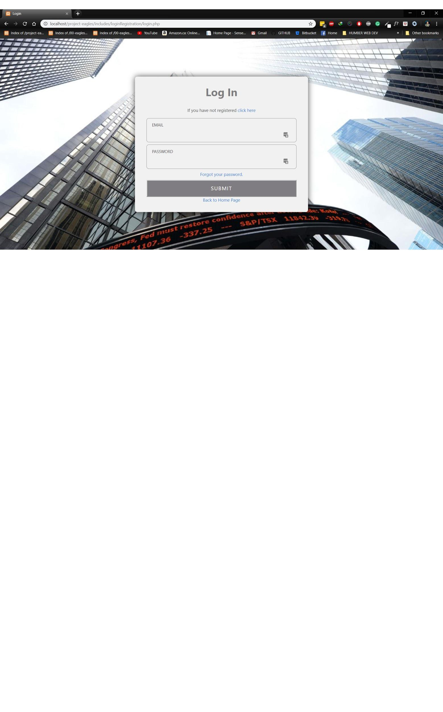

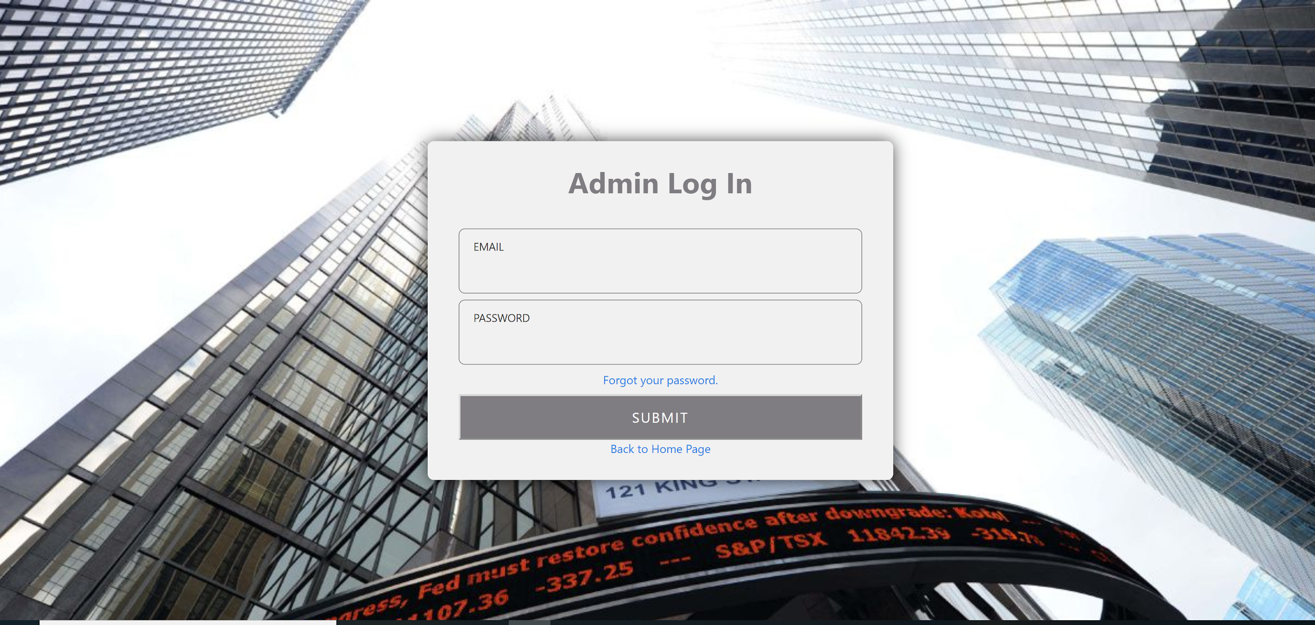

**REGISTER PAGE:**

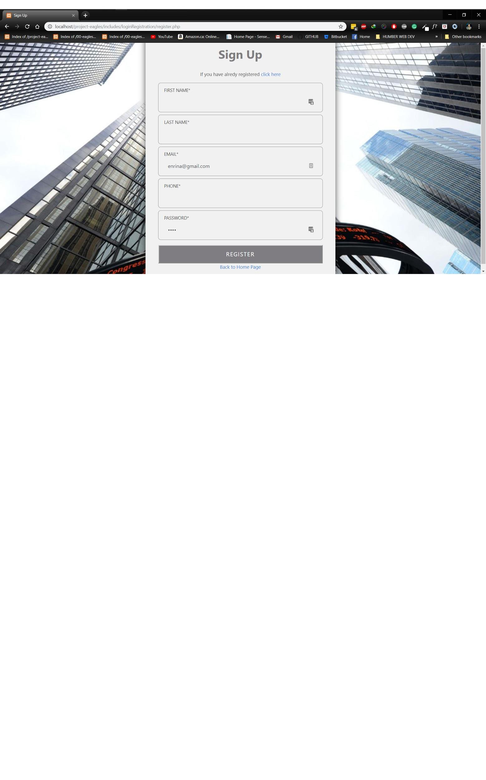

**Users admin Page**

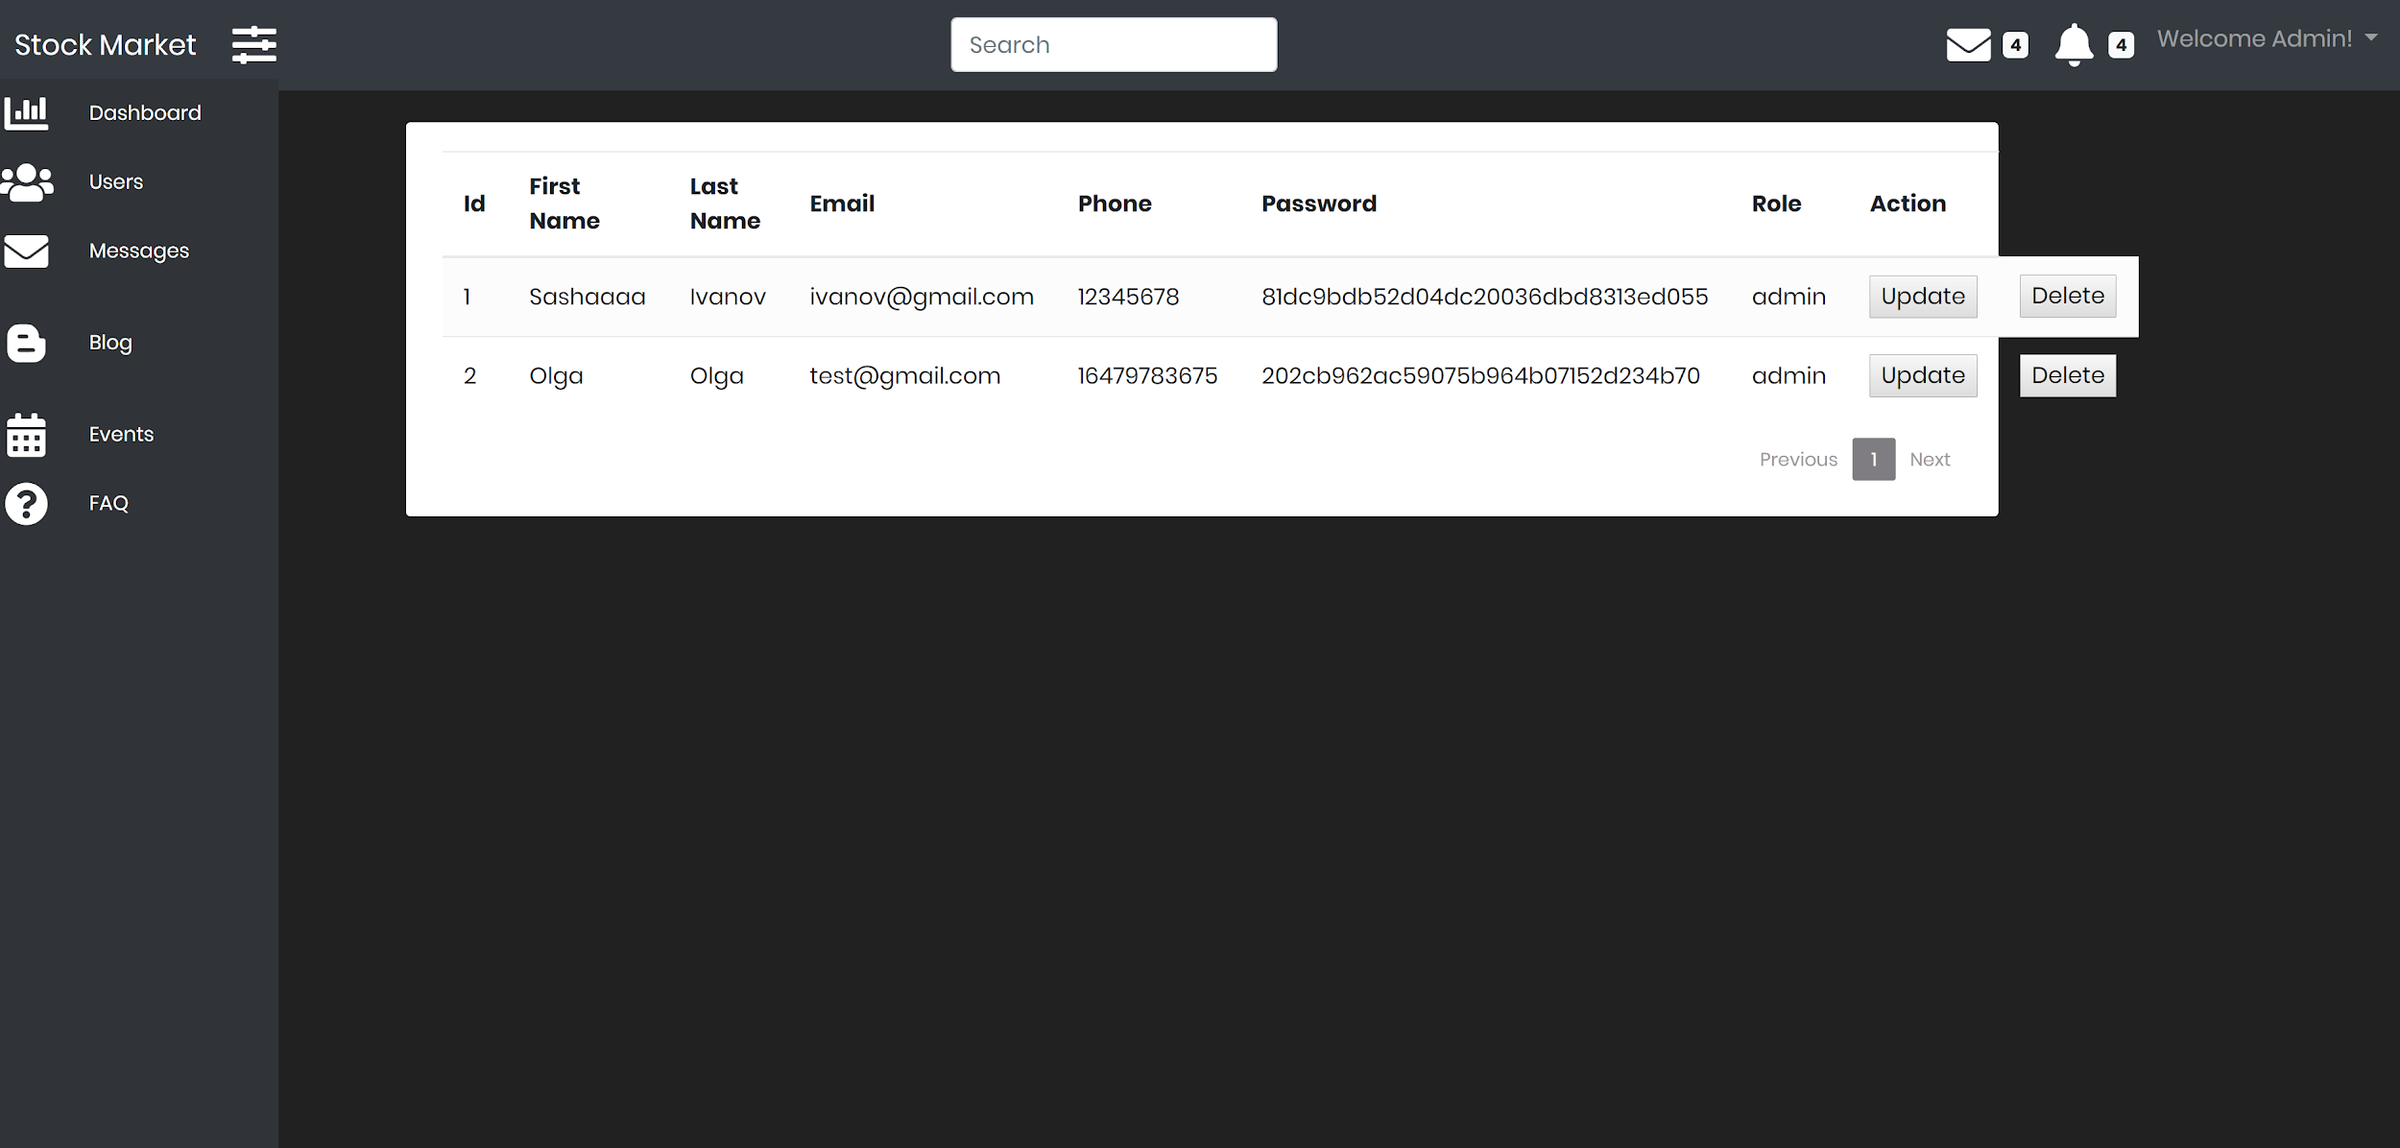

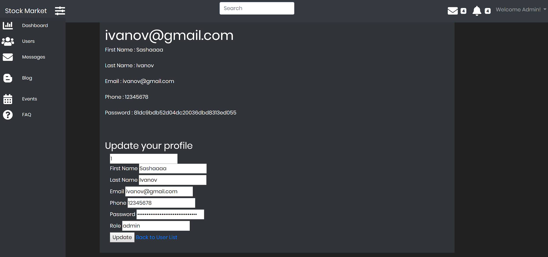

**HOMEPAGE WITH THE USER STATUS POST FEATURE:**

**SIDEBAR IS FOR LIST FOR STATUS POST FEATURE**

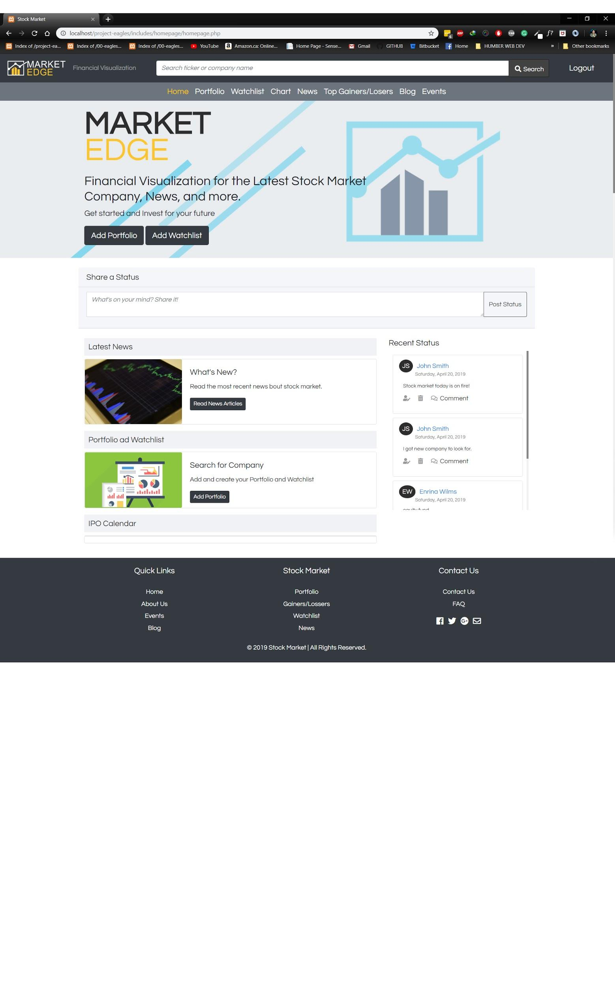

**PORTFOLIO:**

List

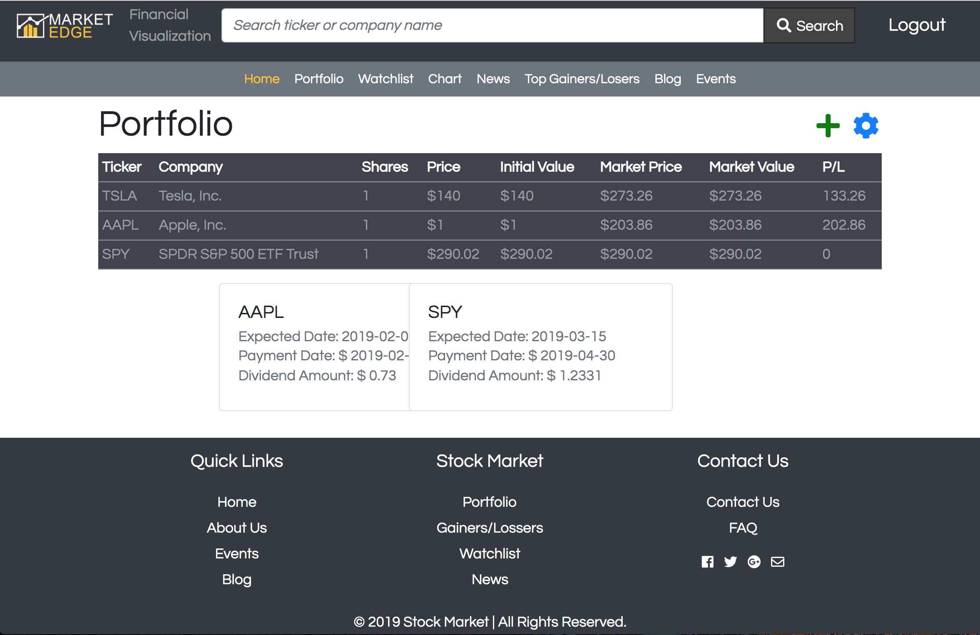

Add

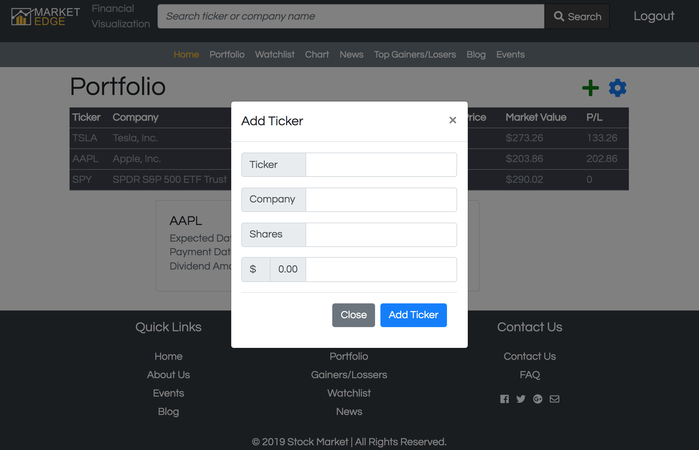

Edit

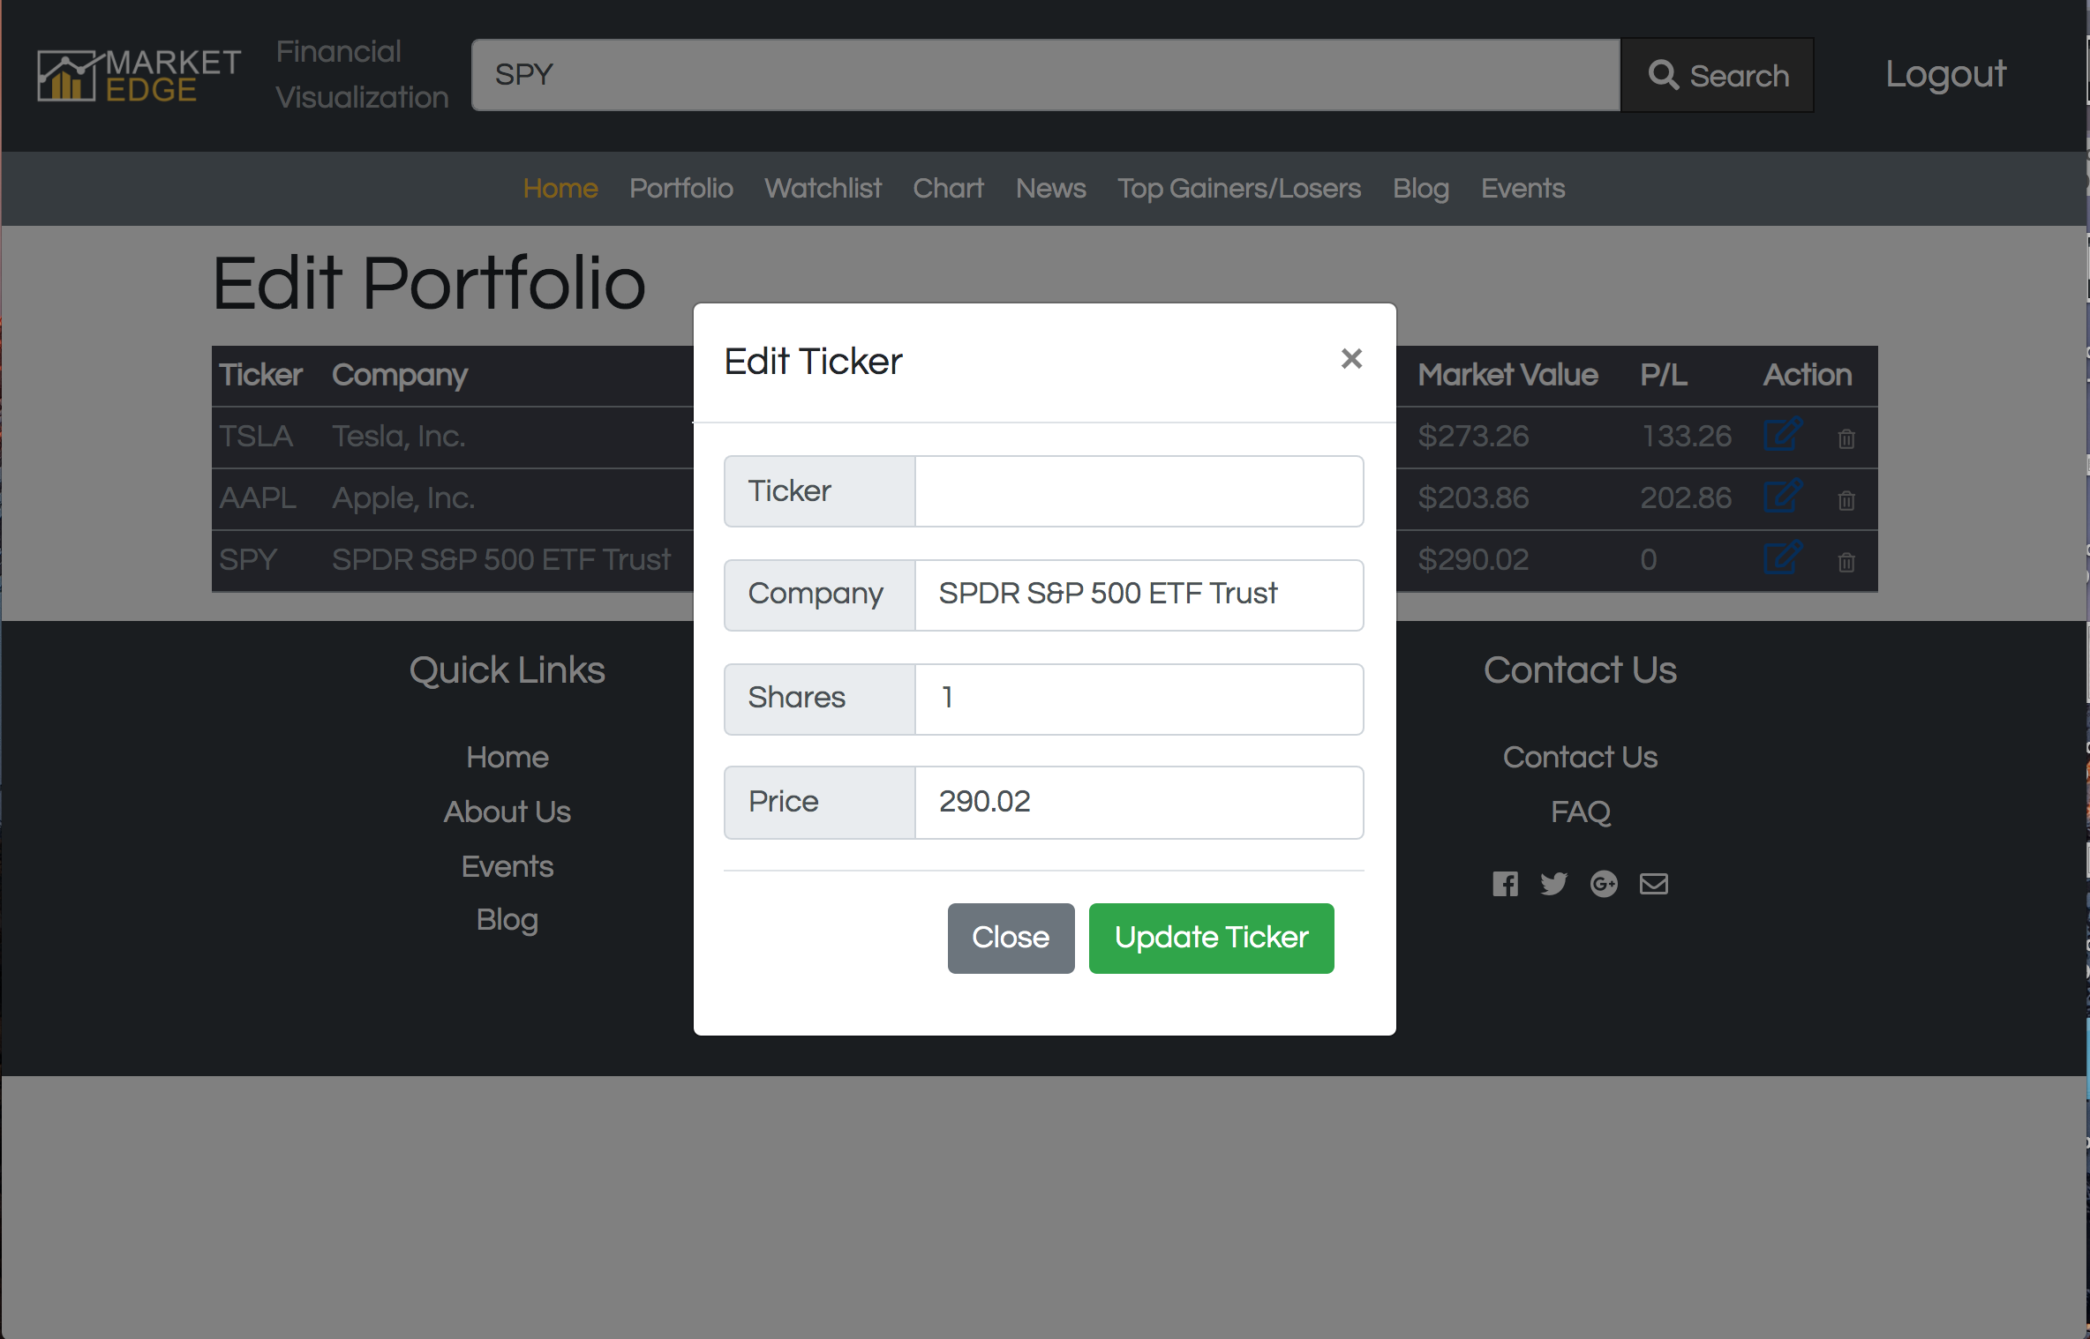

Delete

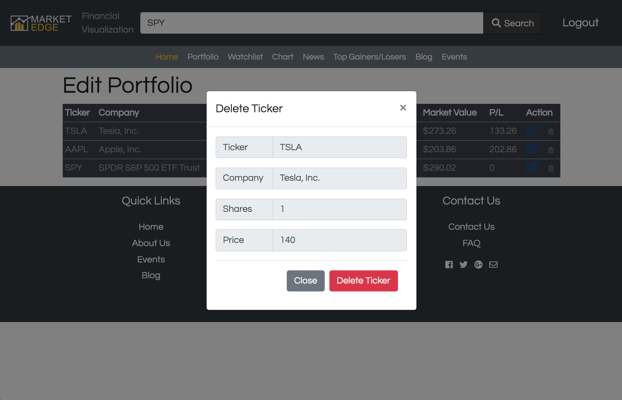

**CHART:**

Chart View

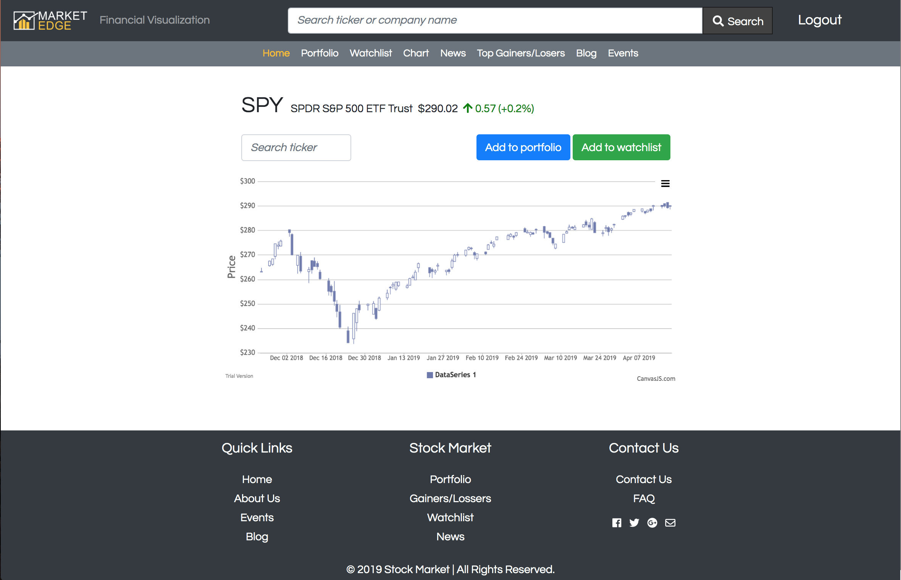

**SEARCH**

Search View

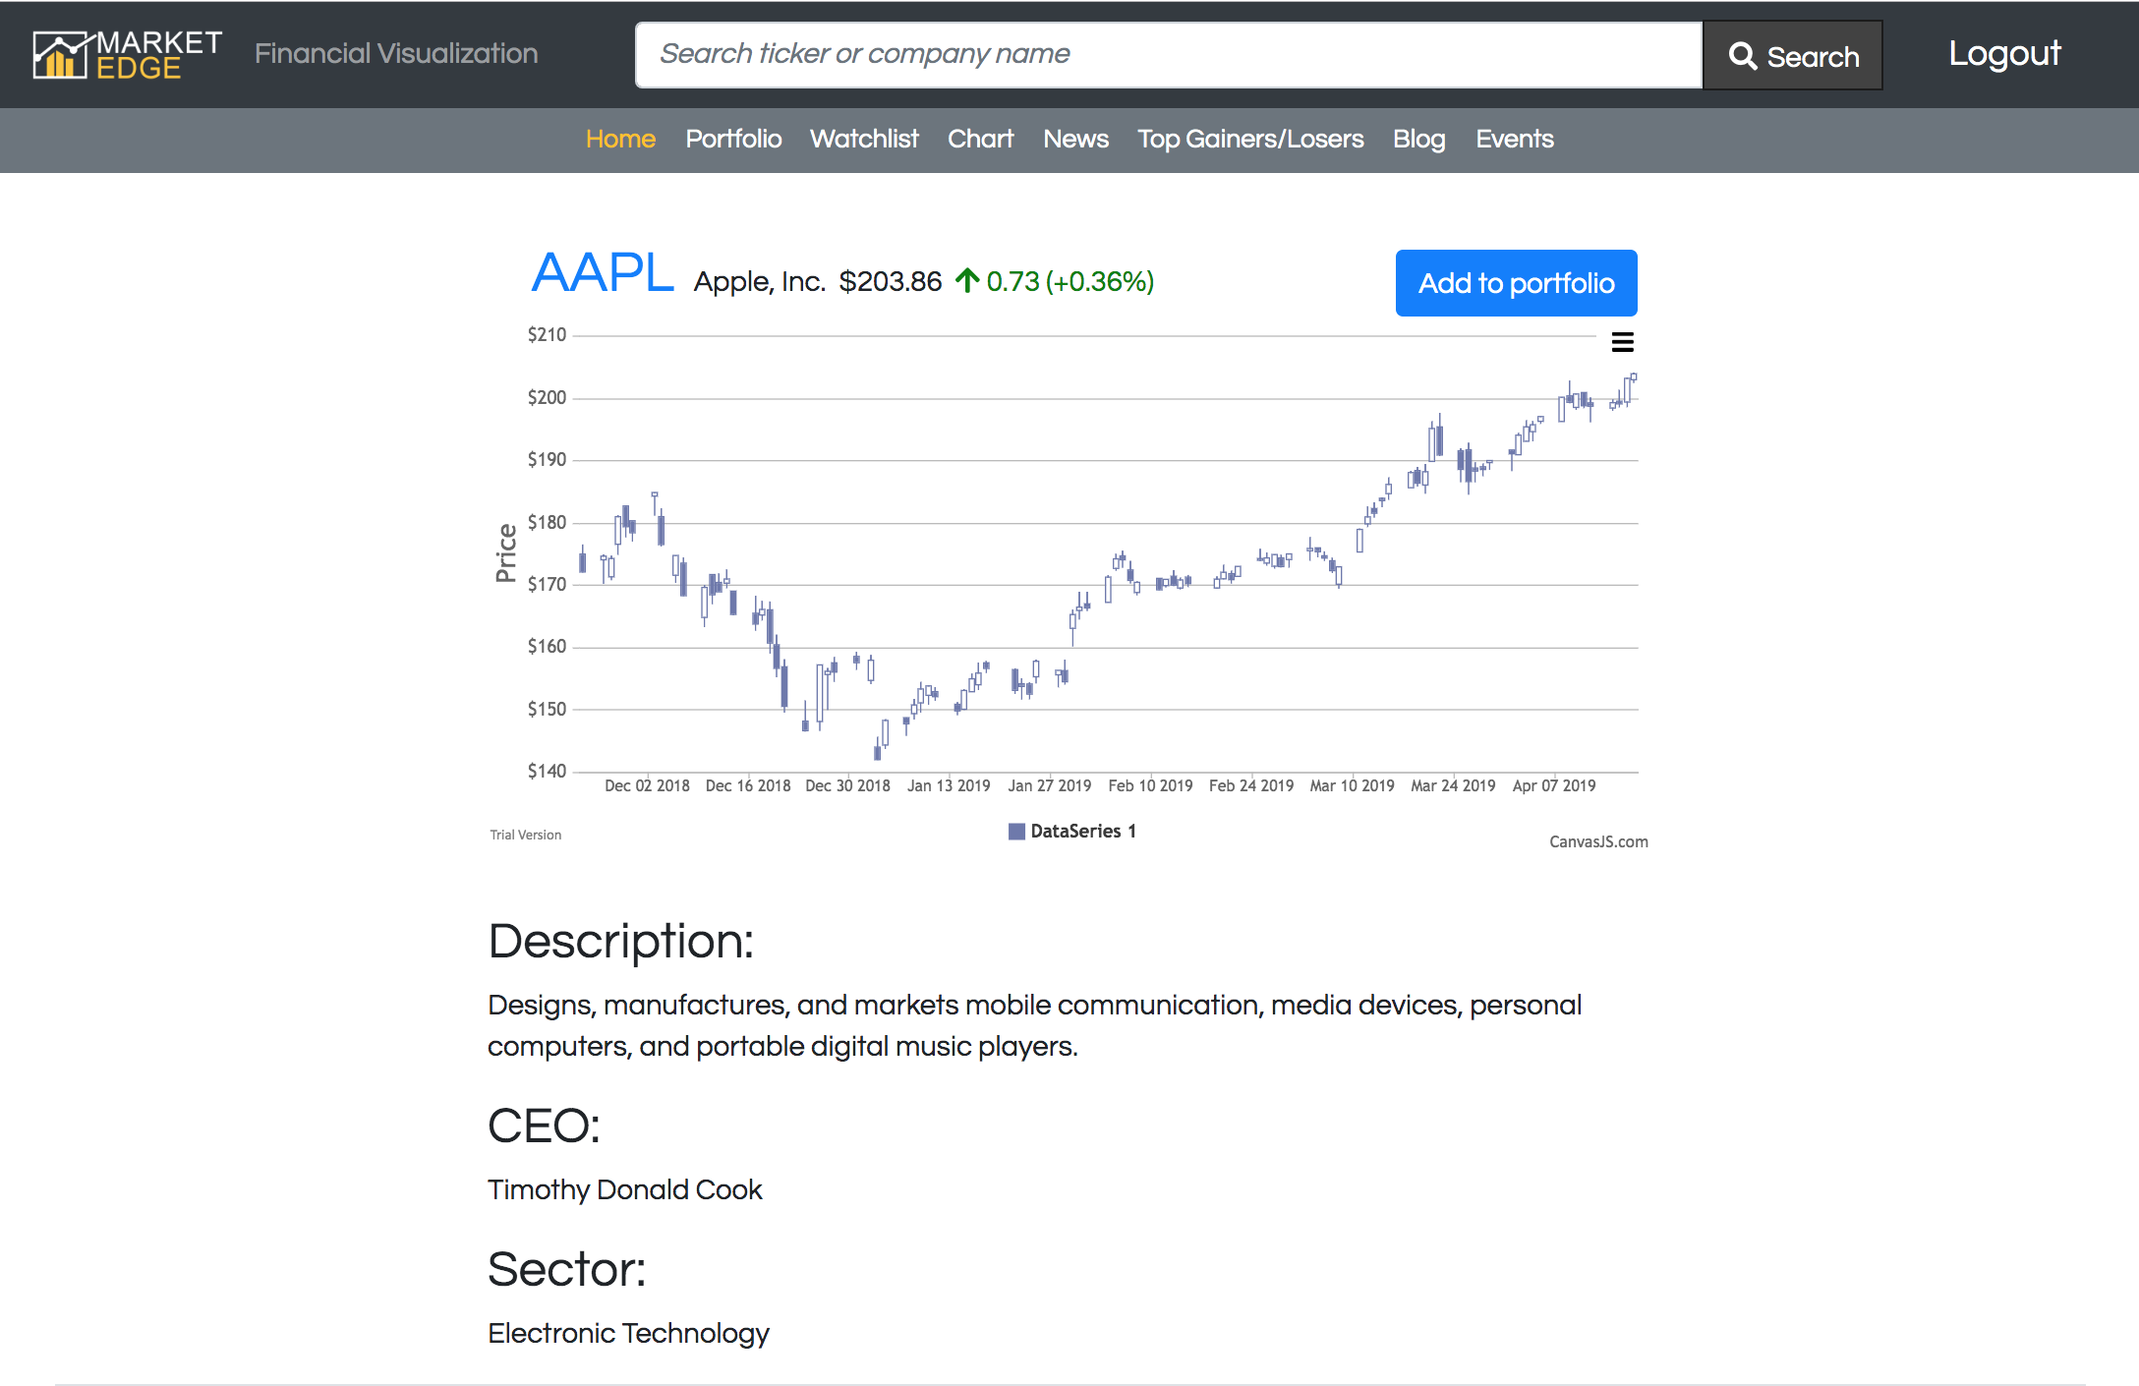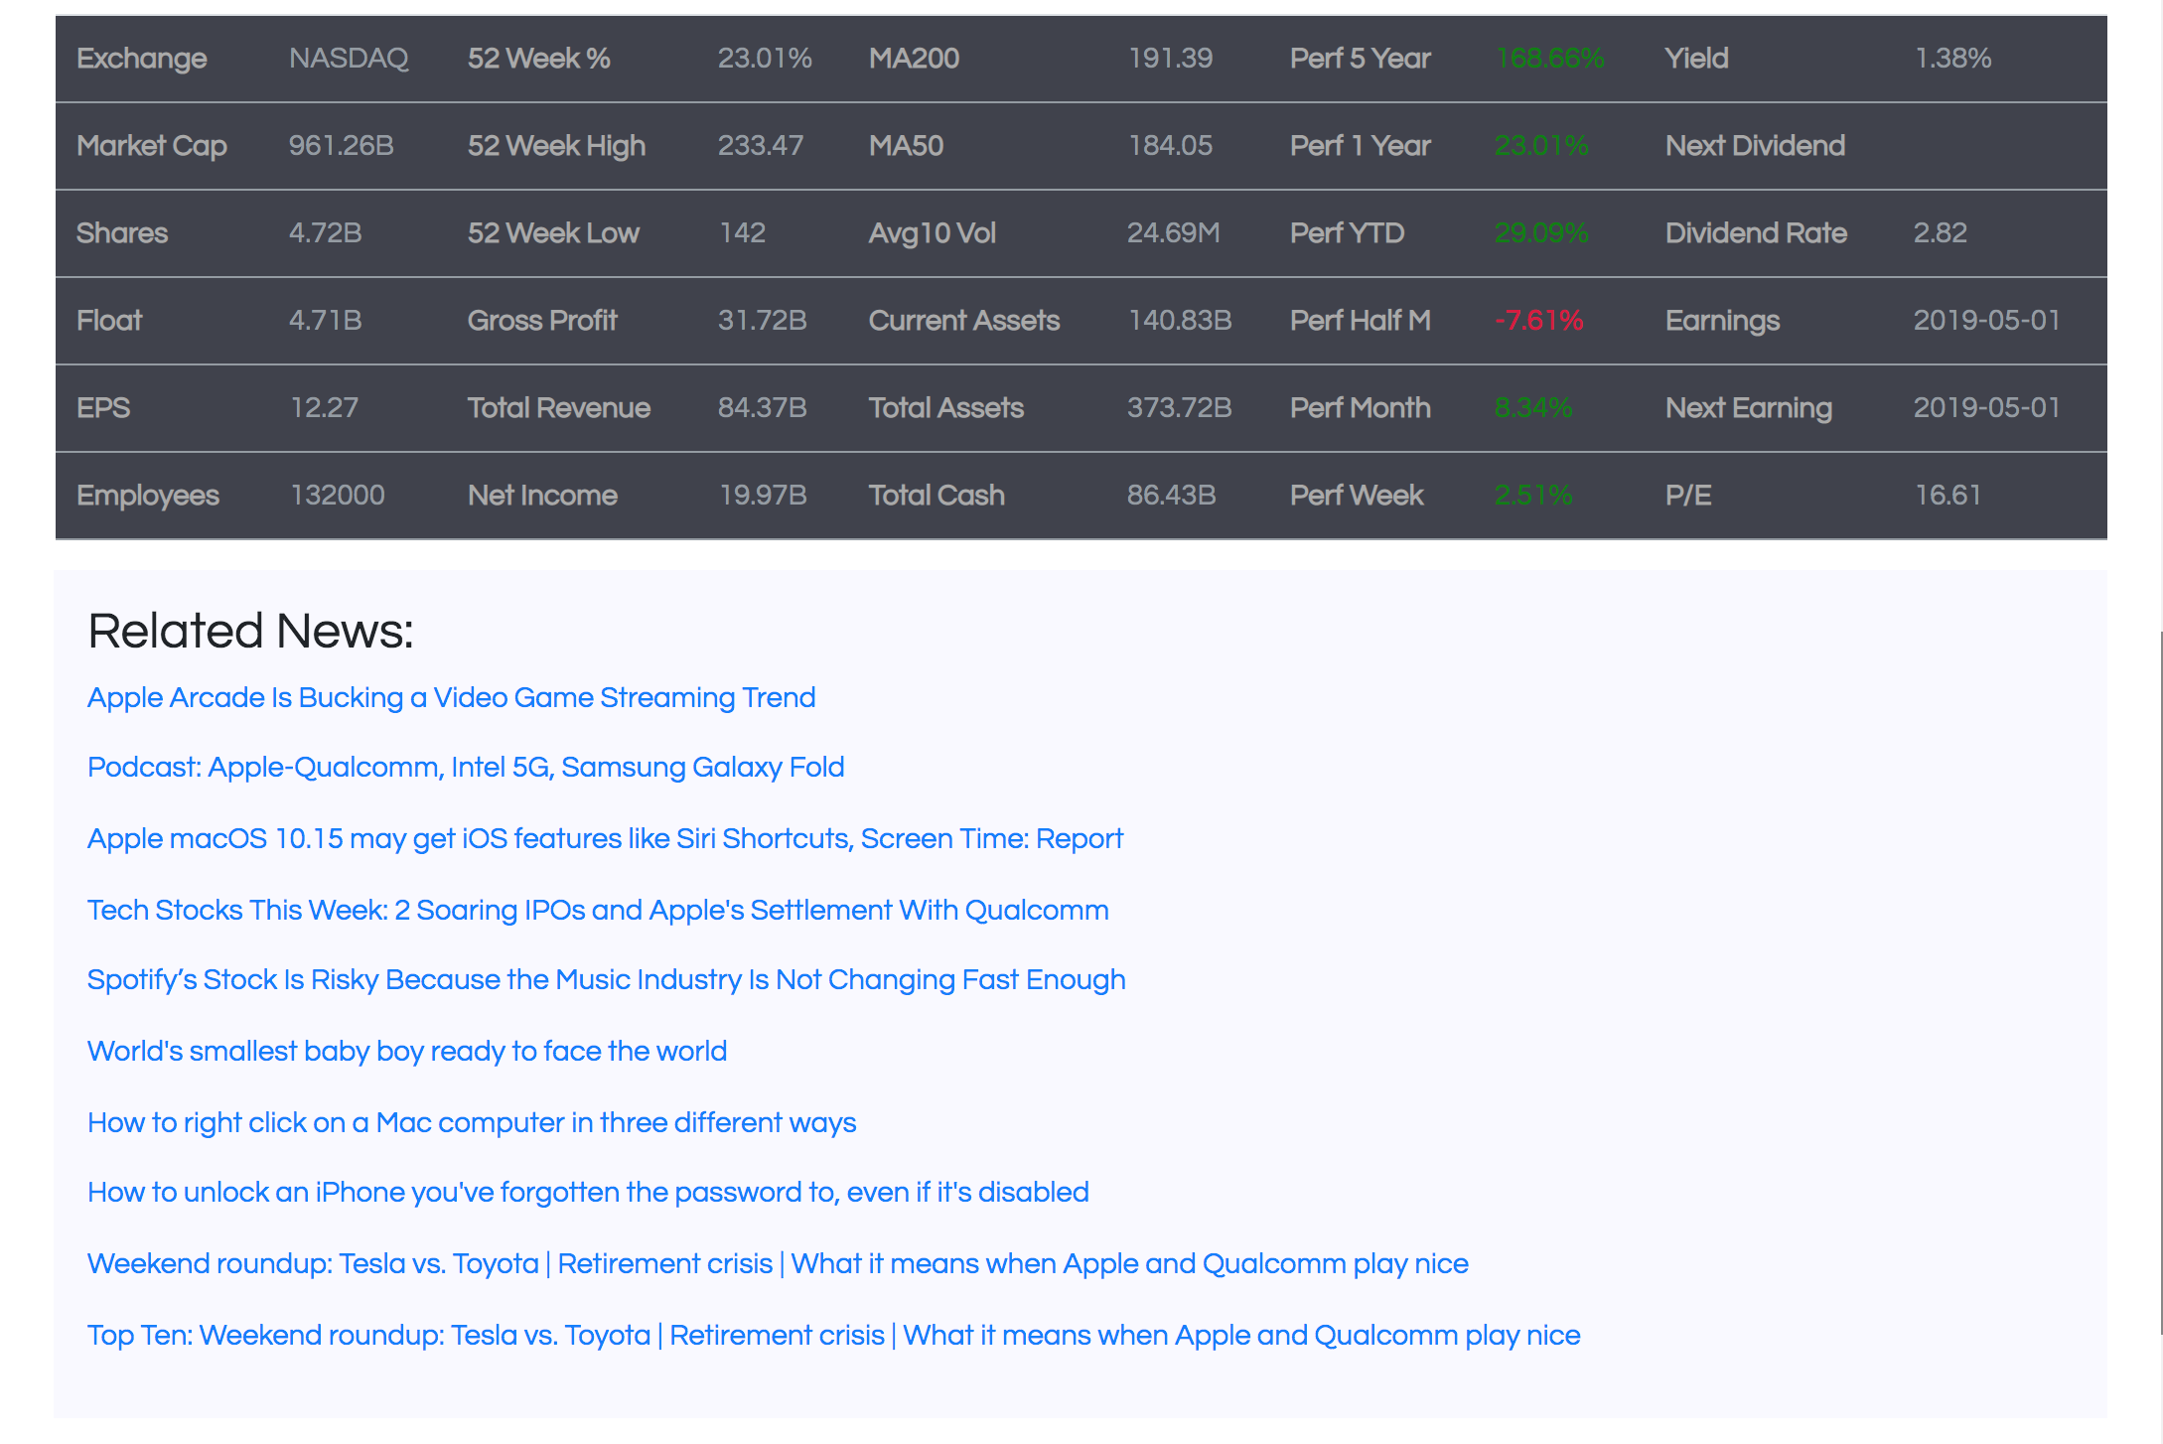

**WATCHLIST:**

1. Watchlist with no data

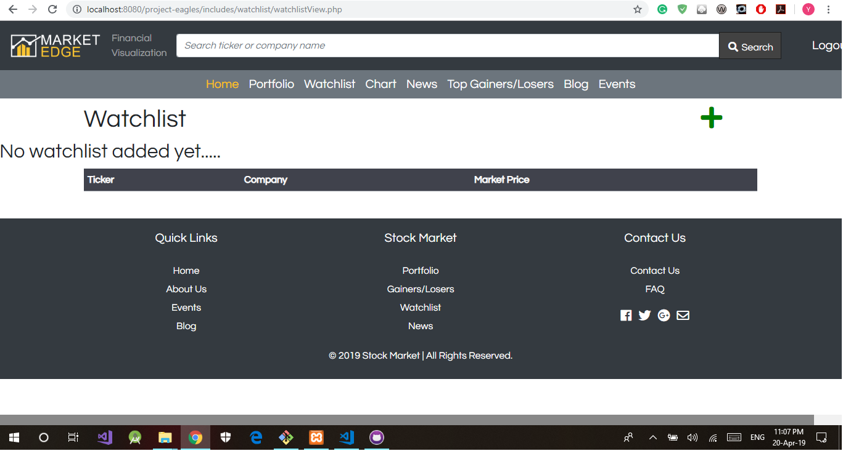

1. Watchlist with data

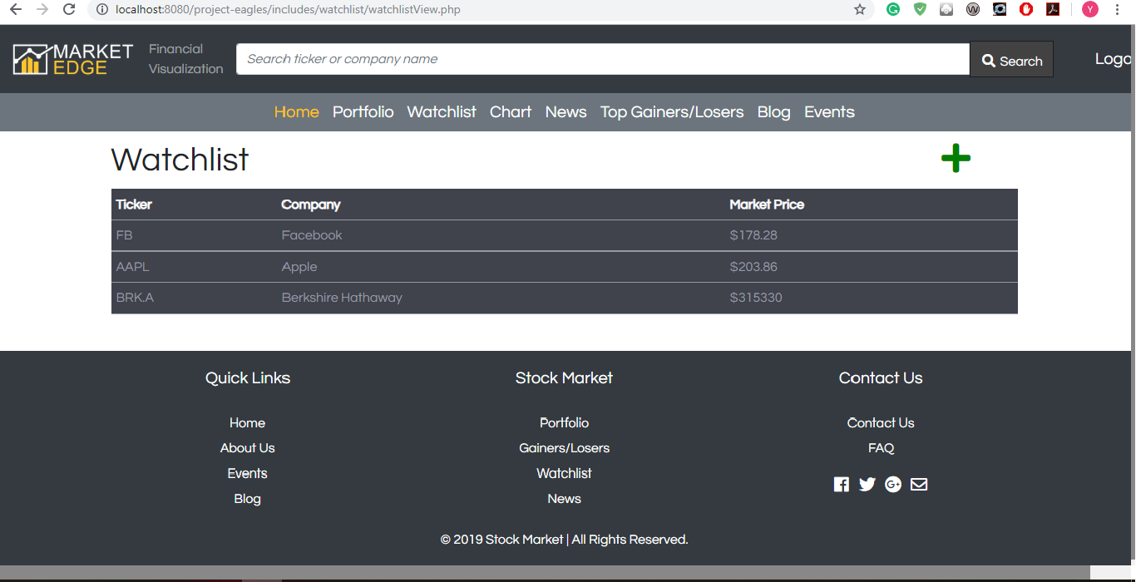

3) Create Watchlist

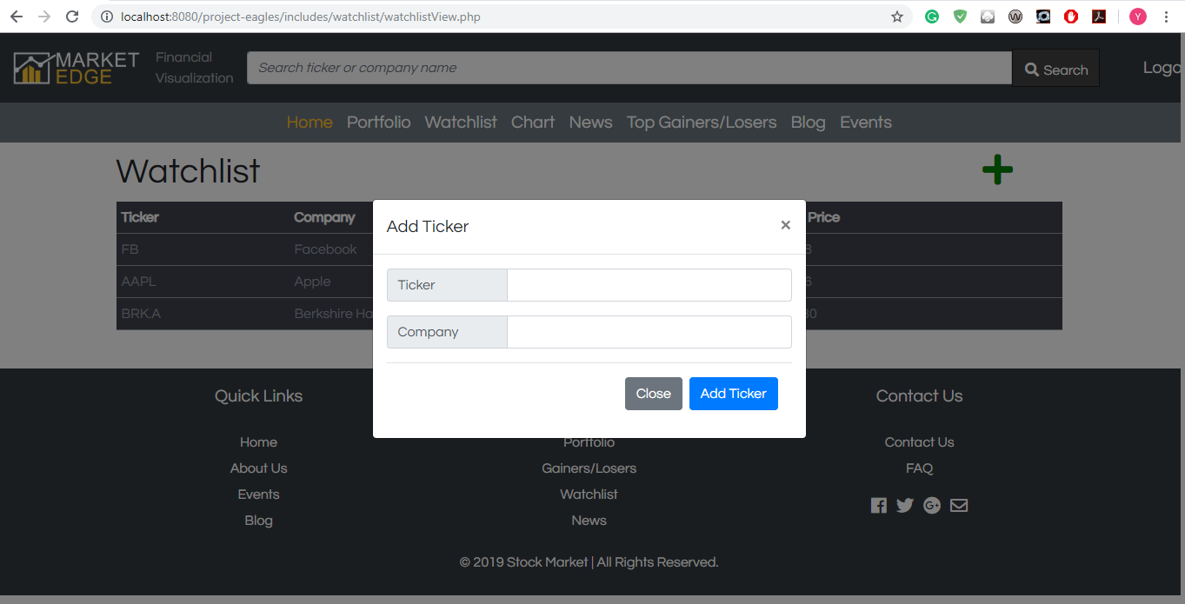

**COMMENTS:**

1. Public Page

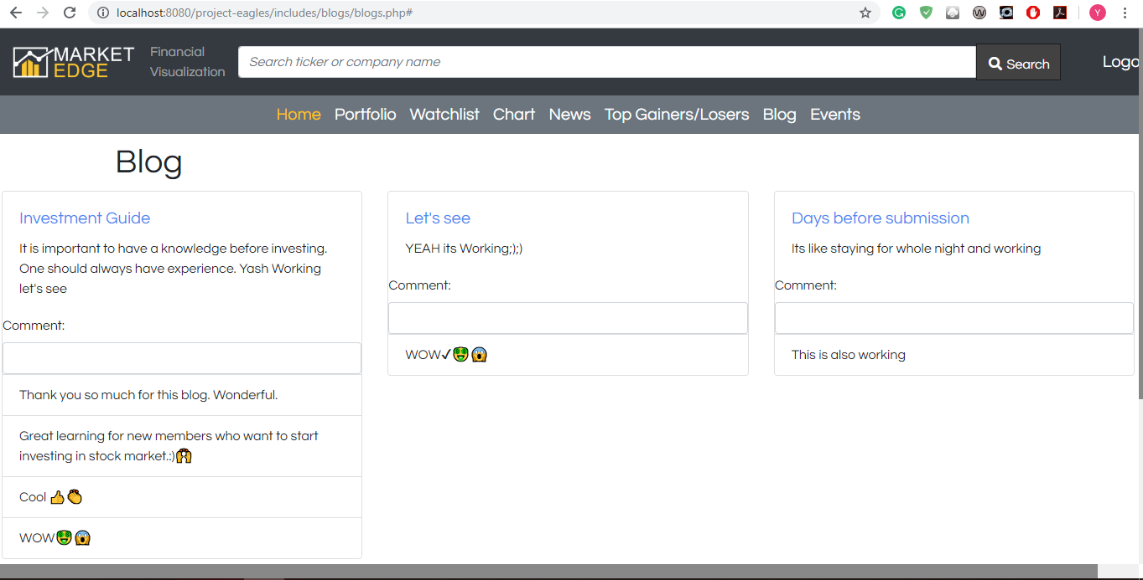

2) Admin Page

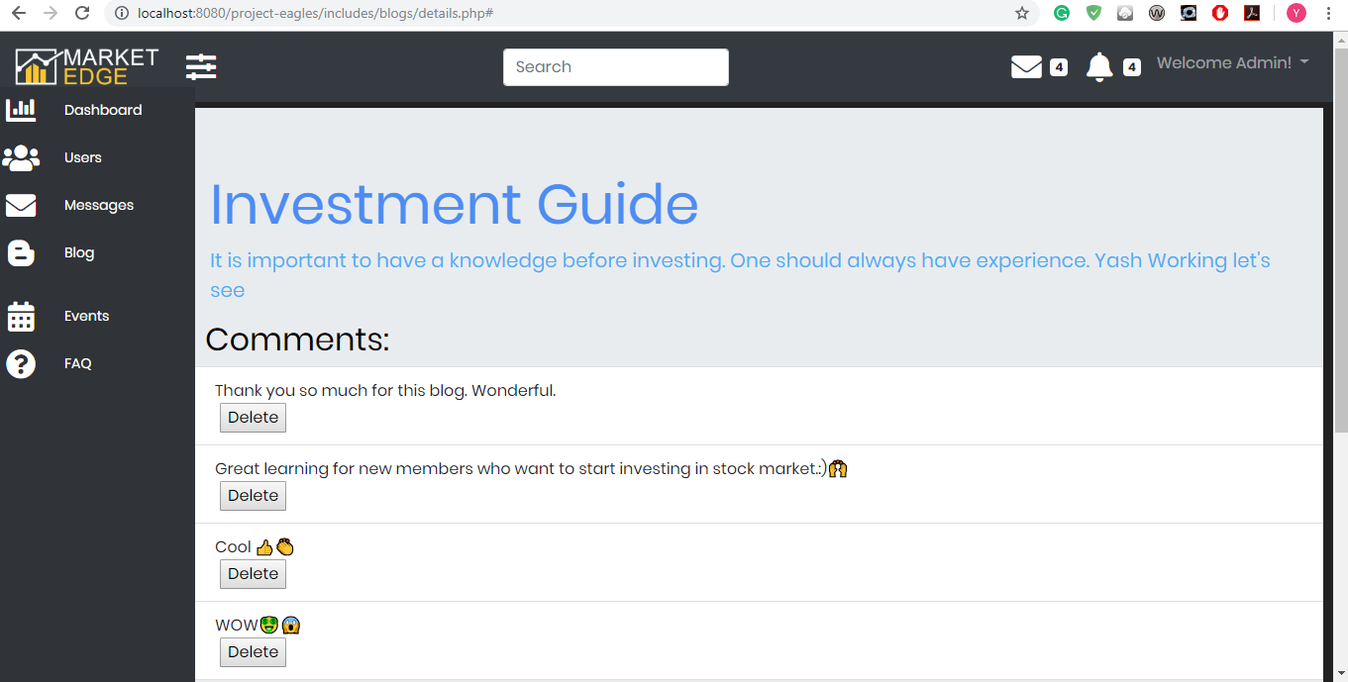

**GAINERS/LOSERS:**

TOP GAINERS TAB

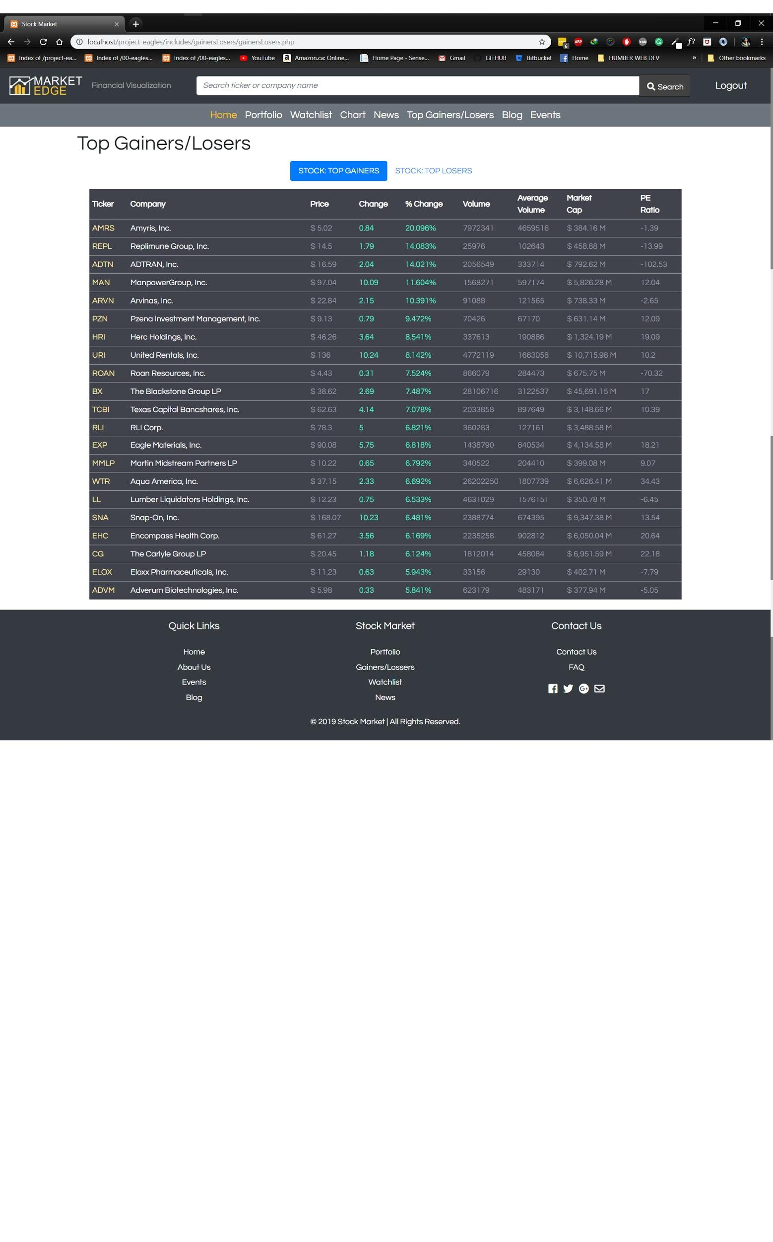

**TOP LOSER TAB**

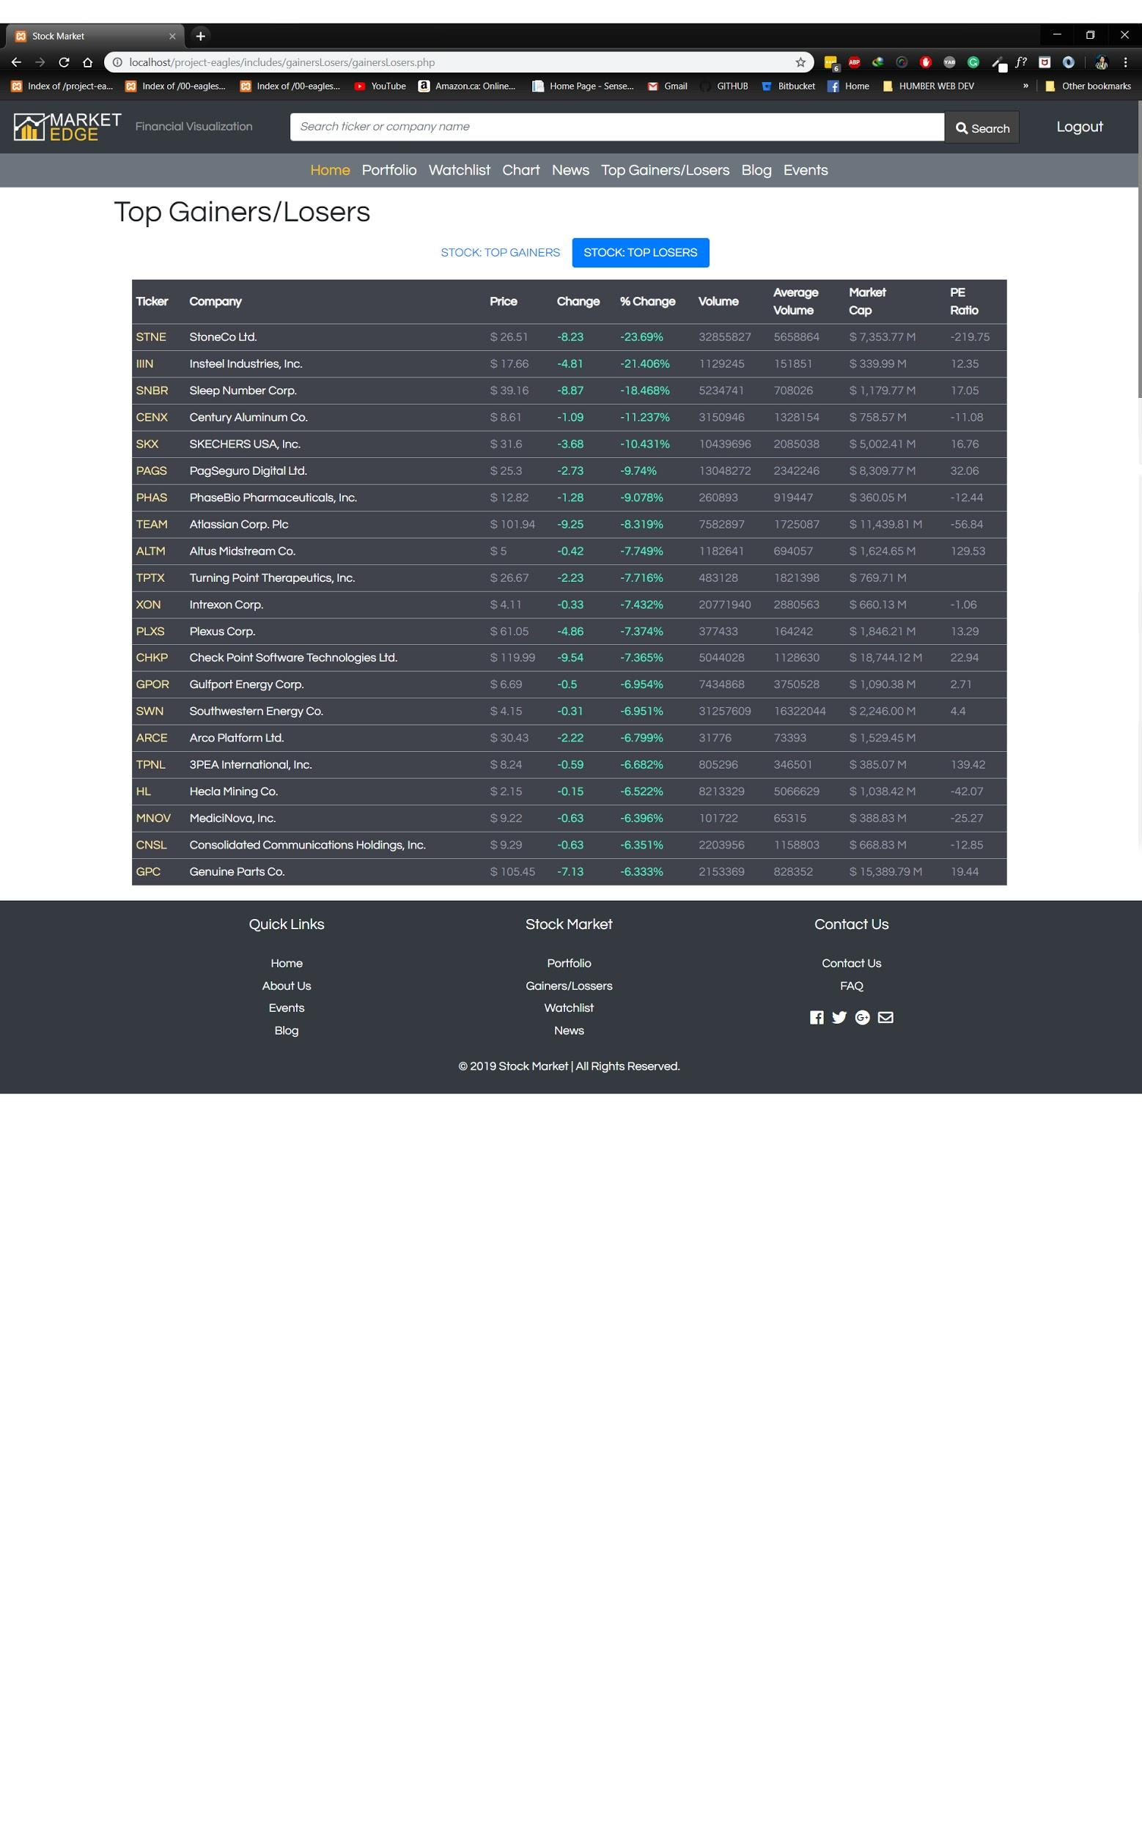

**NEWS:**

MARKETWATCH TAB

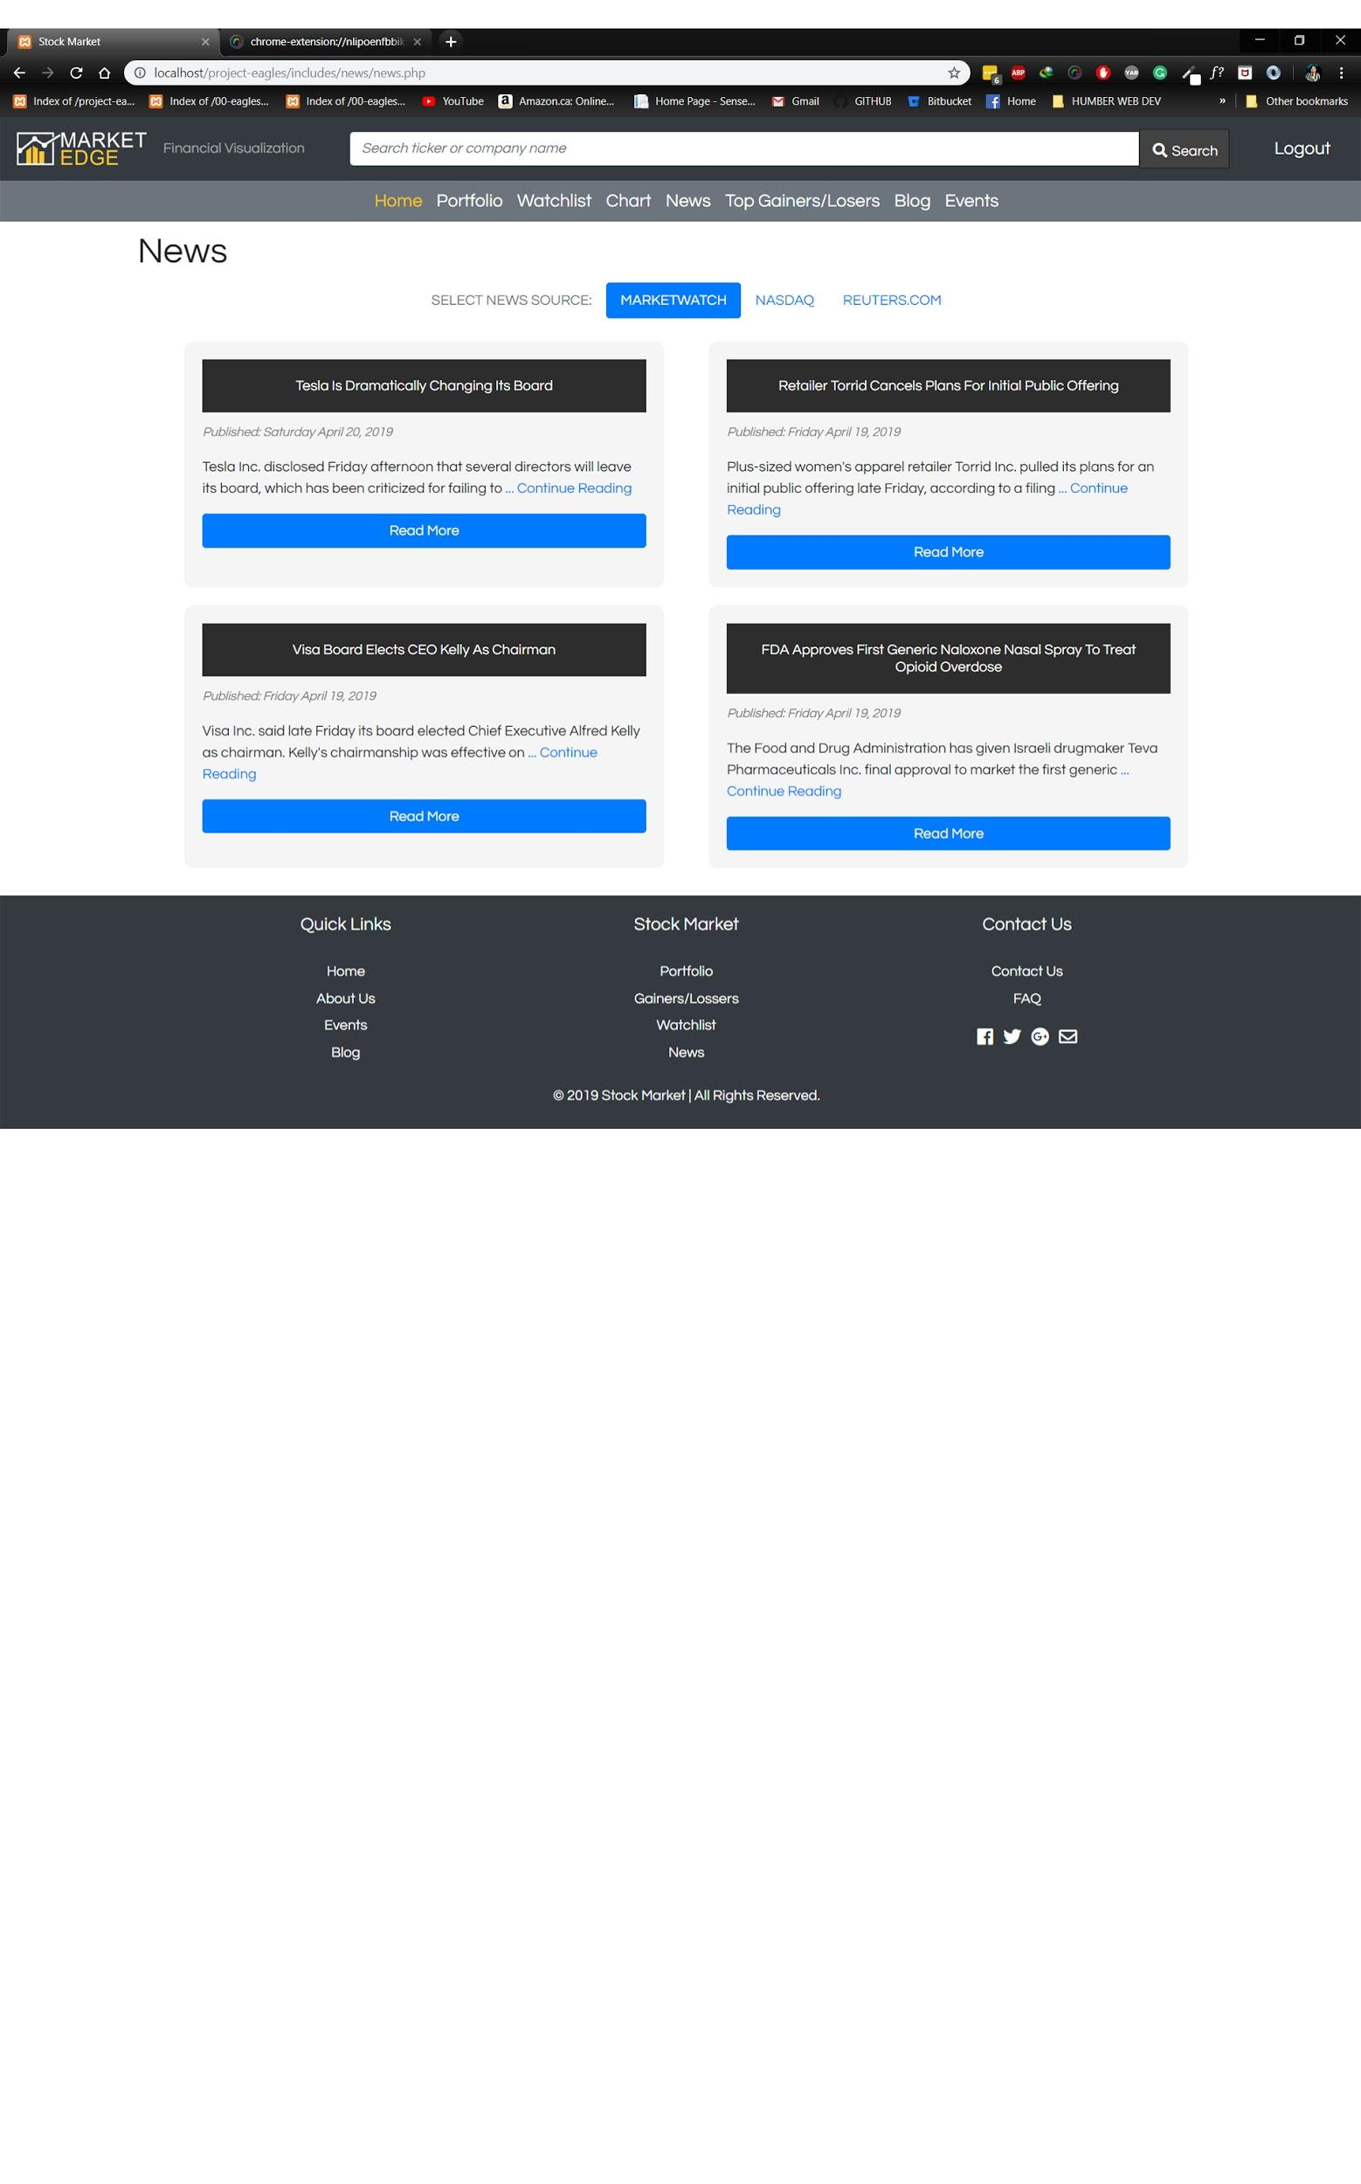

NASDAQ TAB

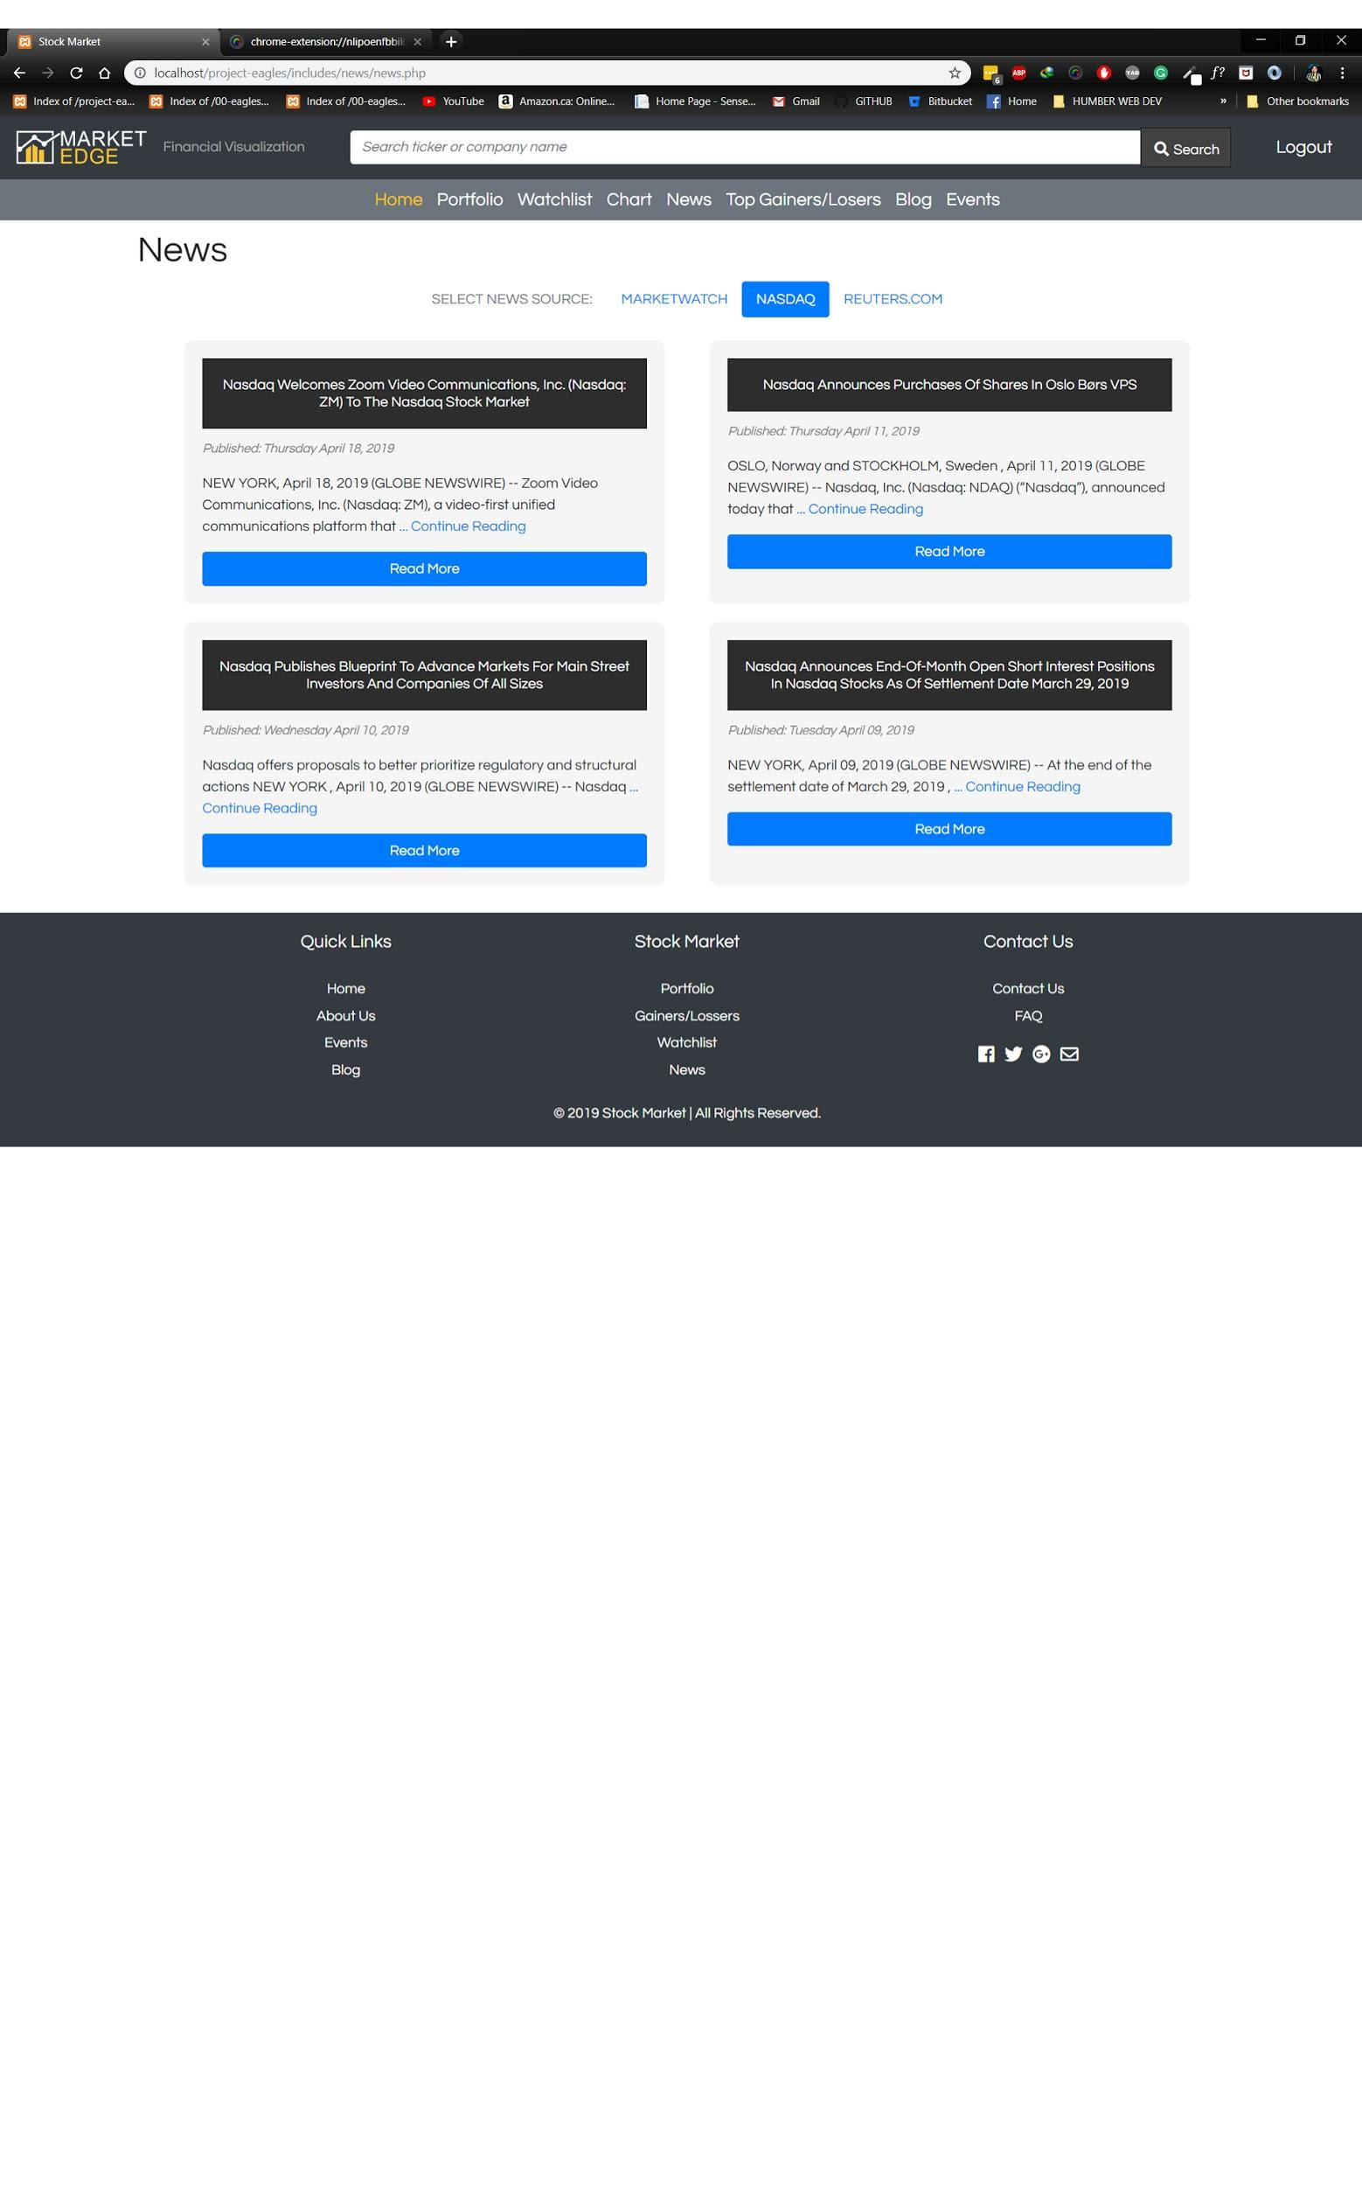

REUTERS.COM TAB

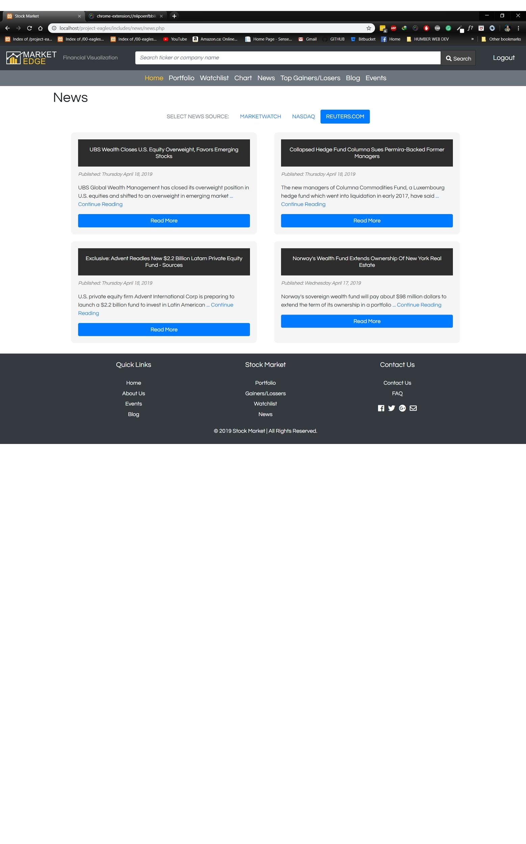

**BLOGS:**

1. Admin View

* View all blogs

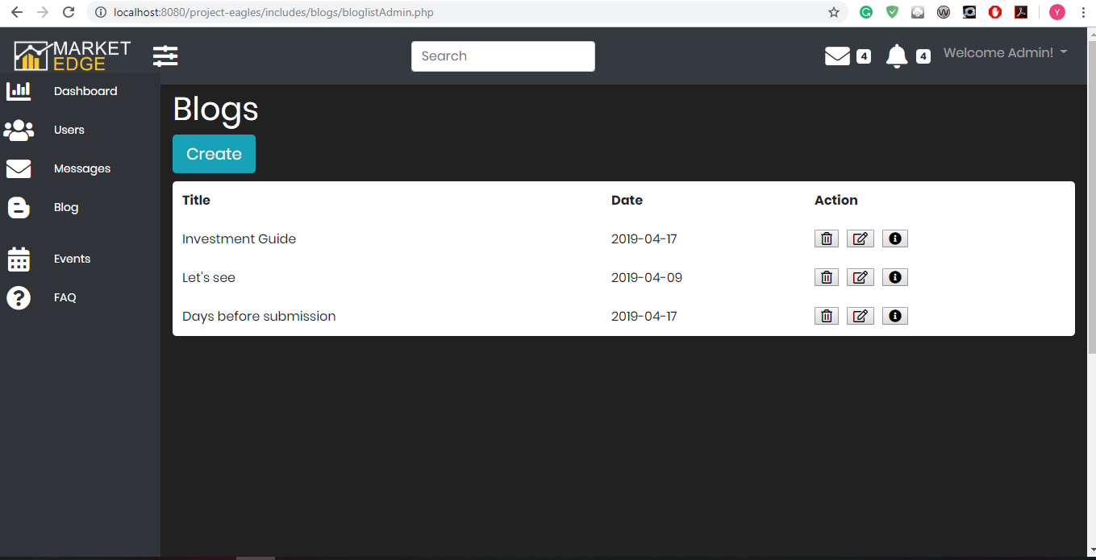

* Create a Blog

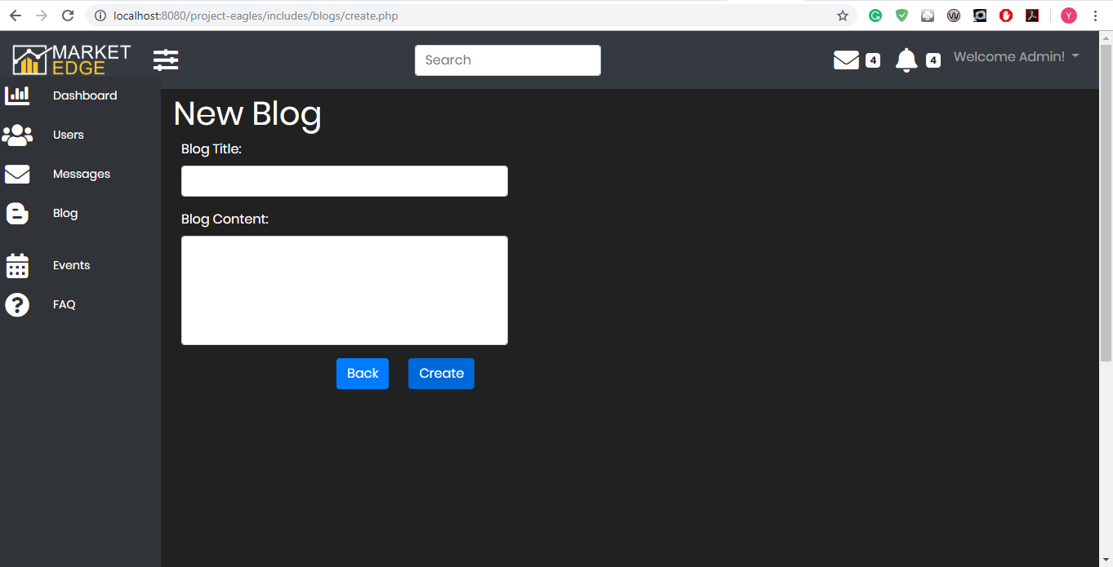

* Edit Blog

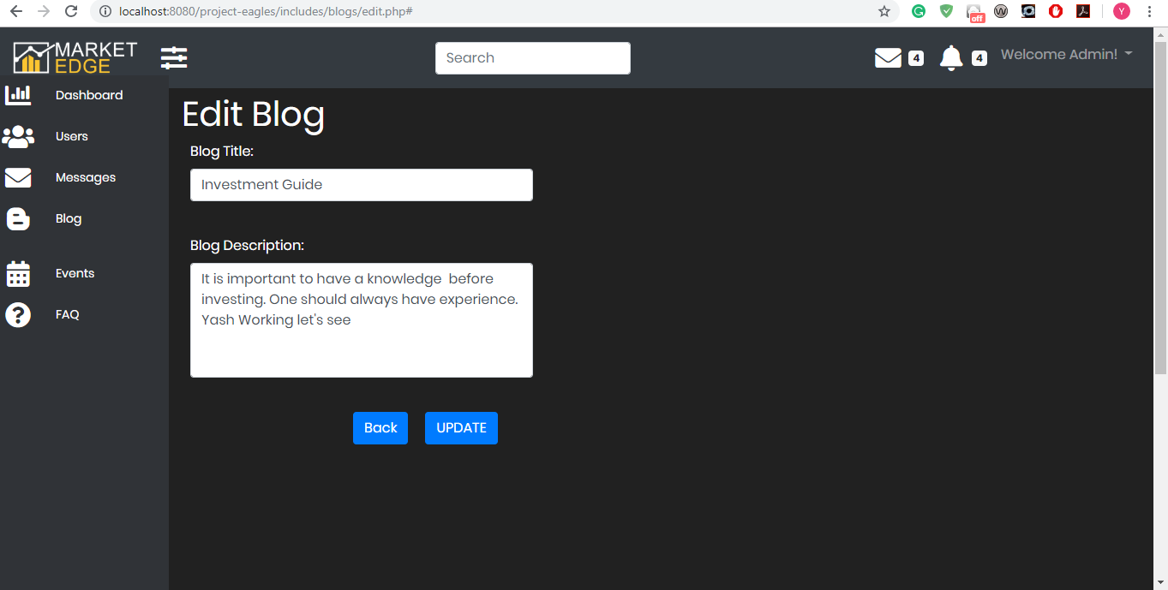

* Blog details



2) Public View



**EVENTS:**

EVENTS PAGE TOP

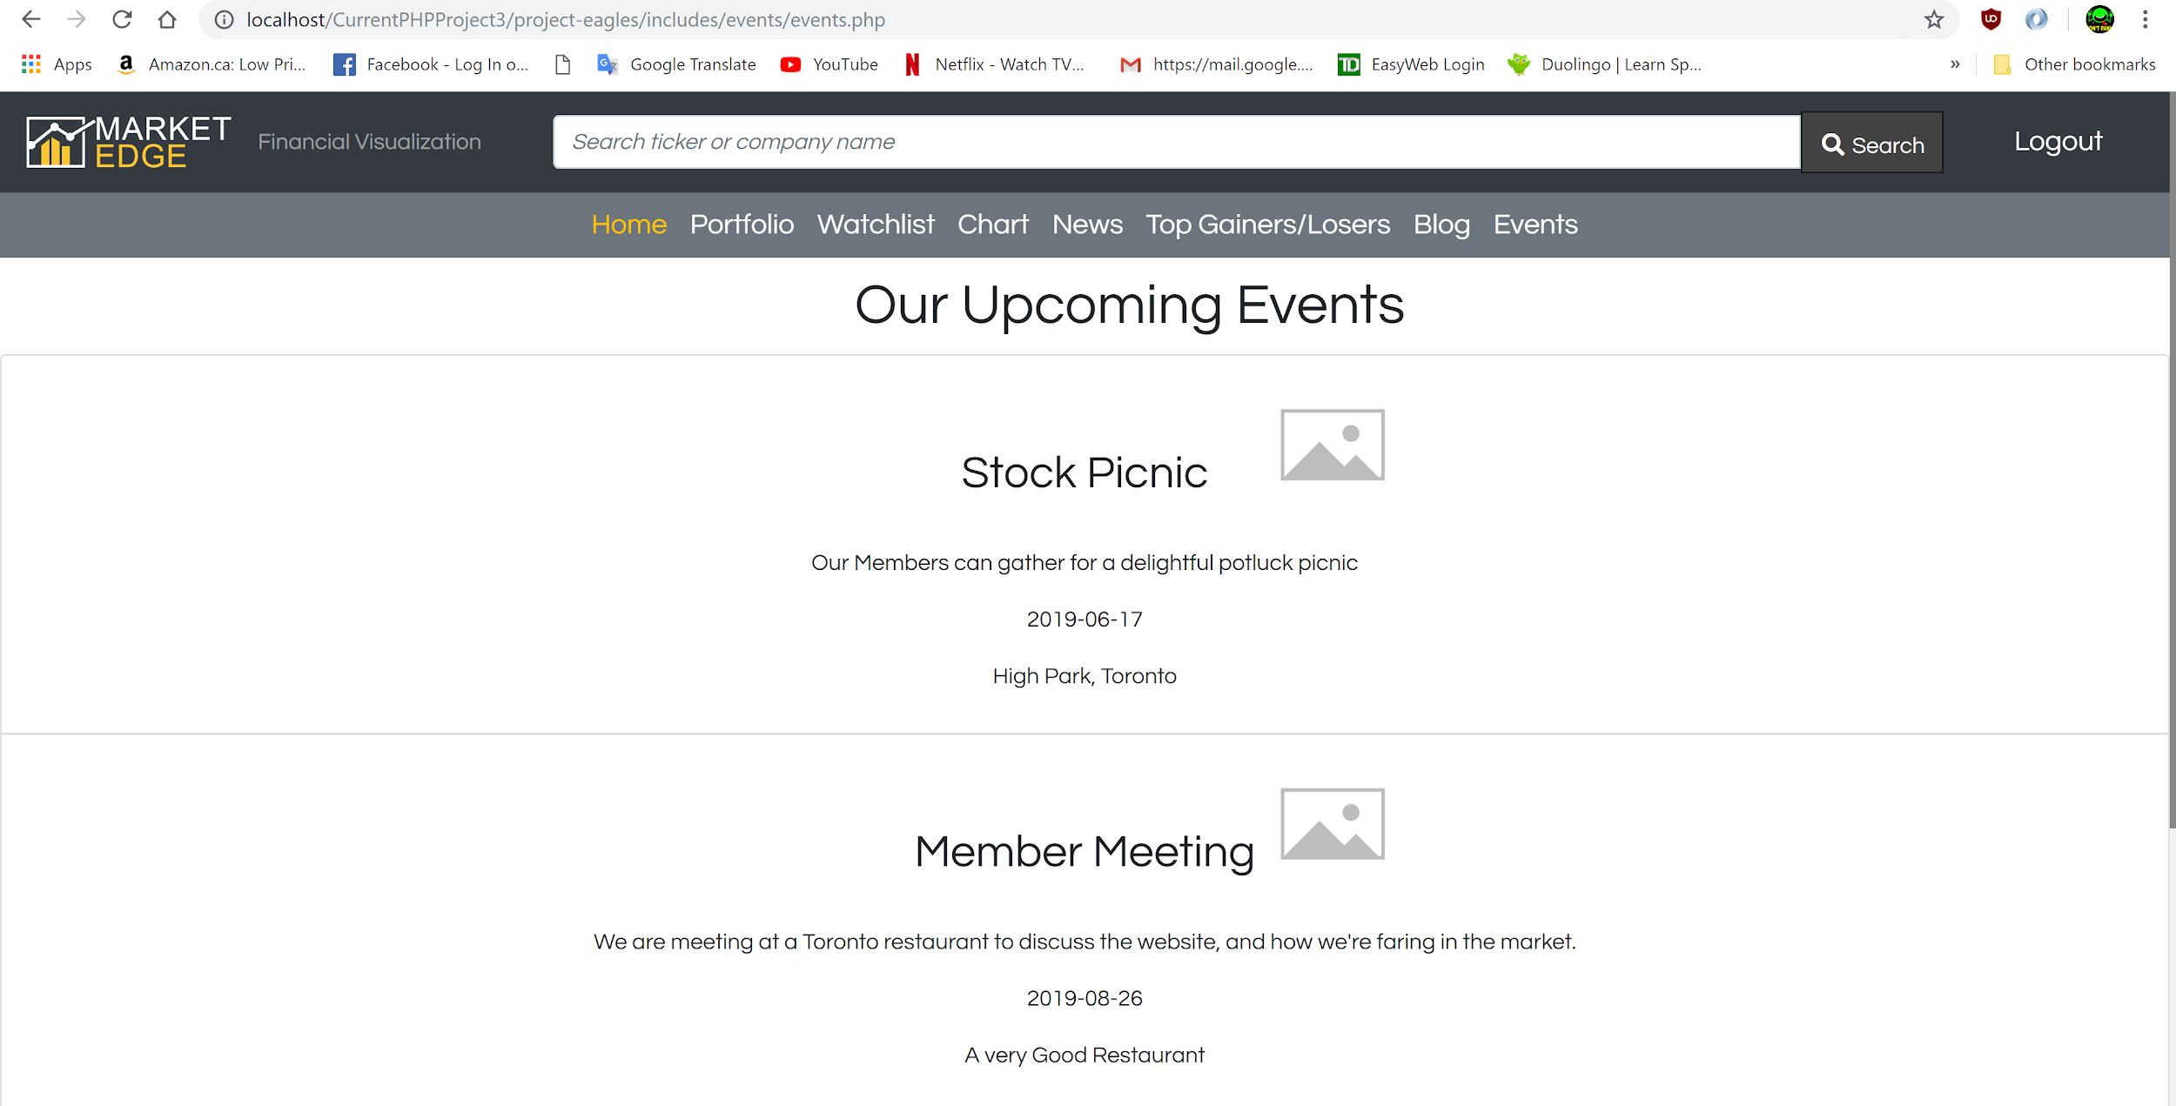

EVENTS PAGE BOTTOM

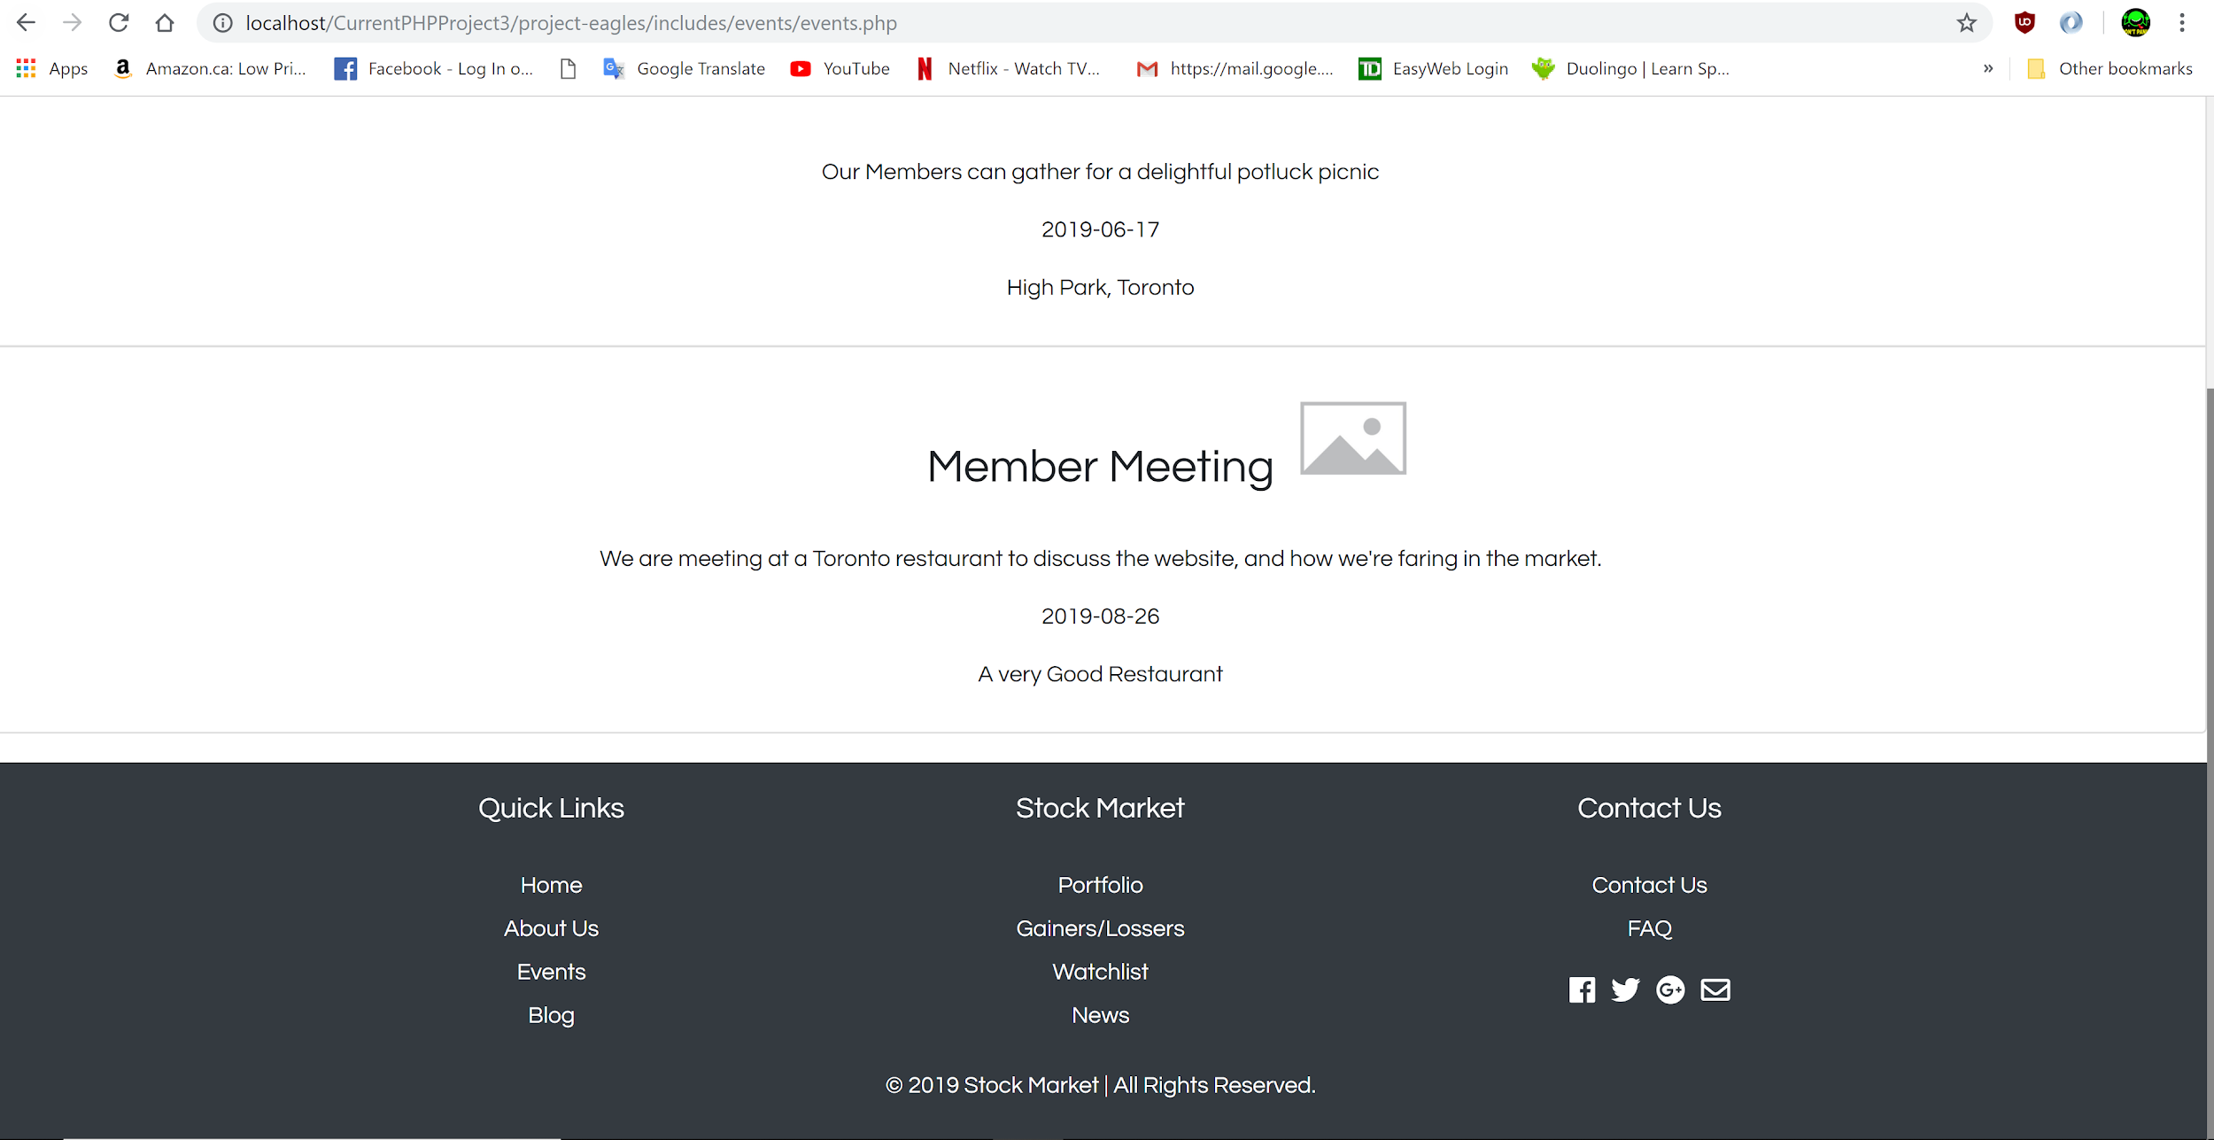

**EVENTS ADMIN PAGE**

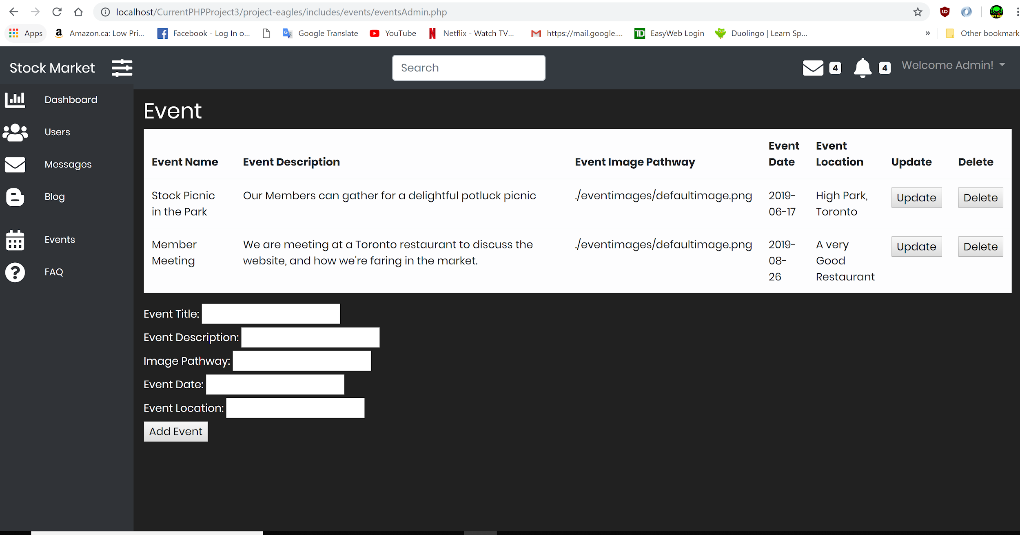

**FAQS PAGE:**

FAQ TOP

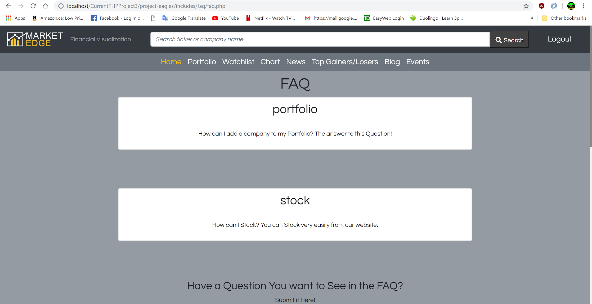

FAQ MIDDLE

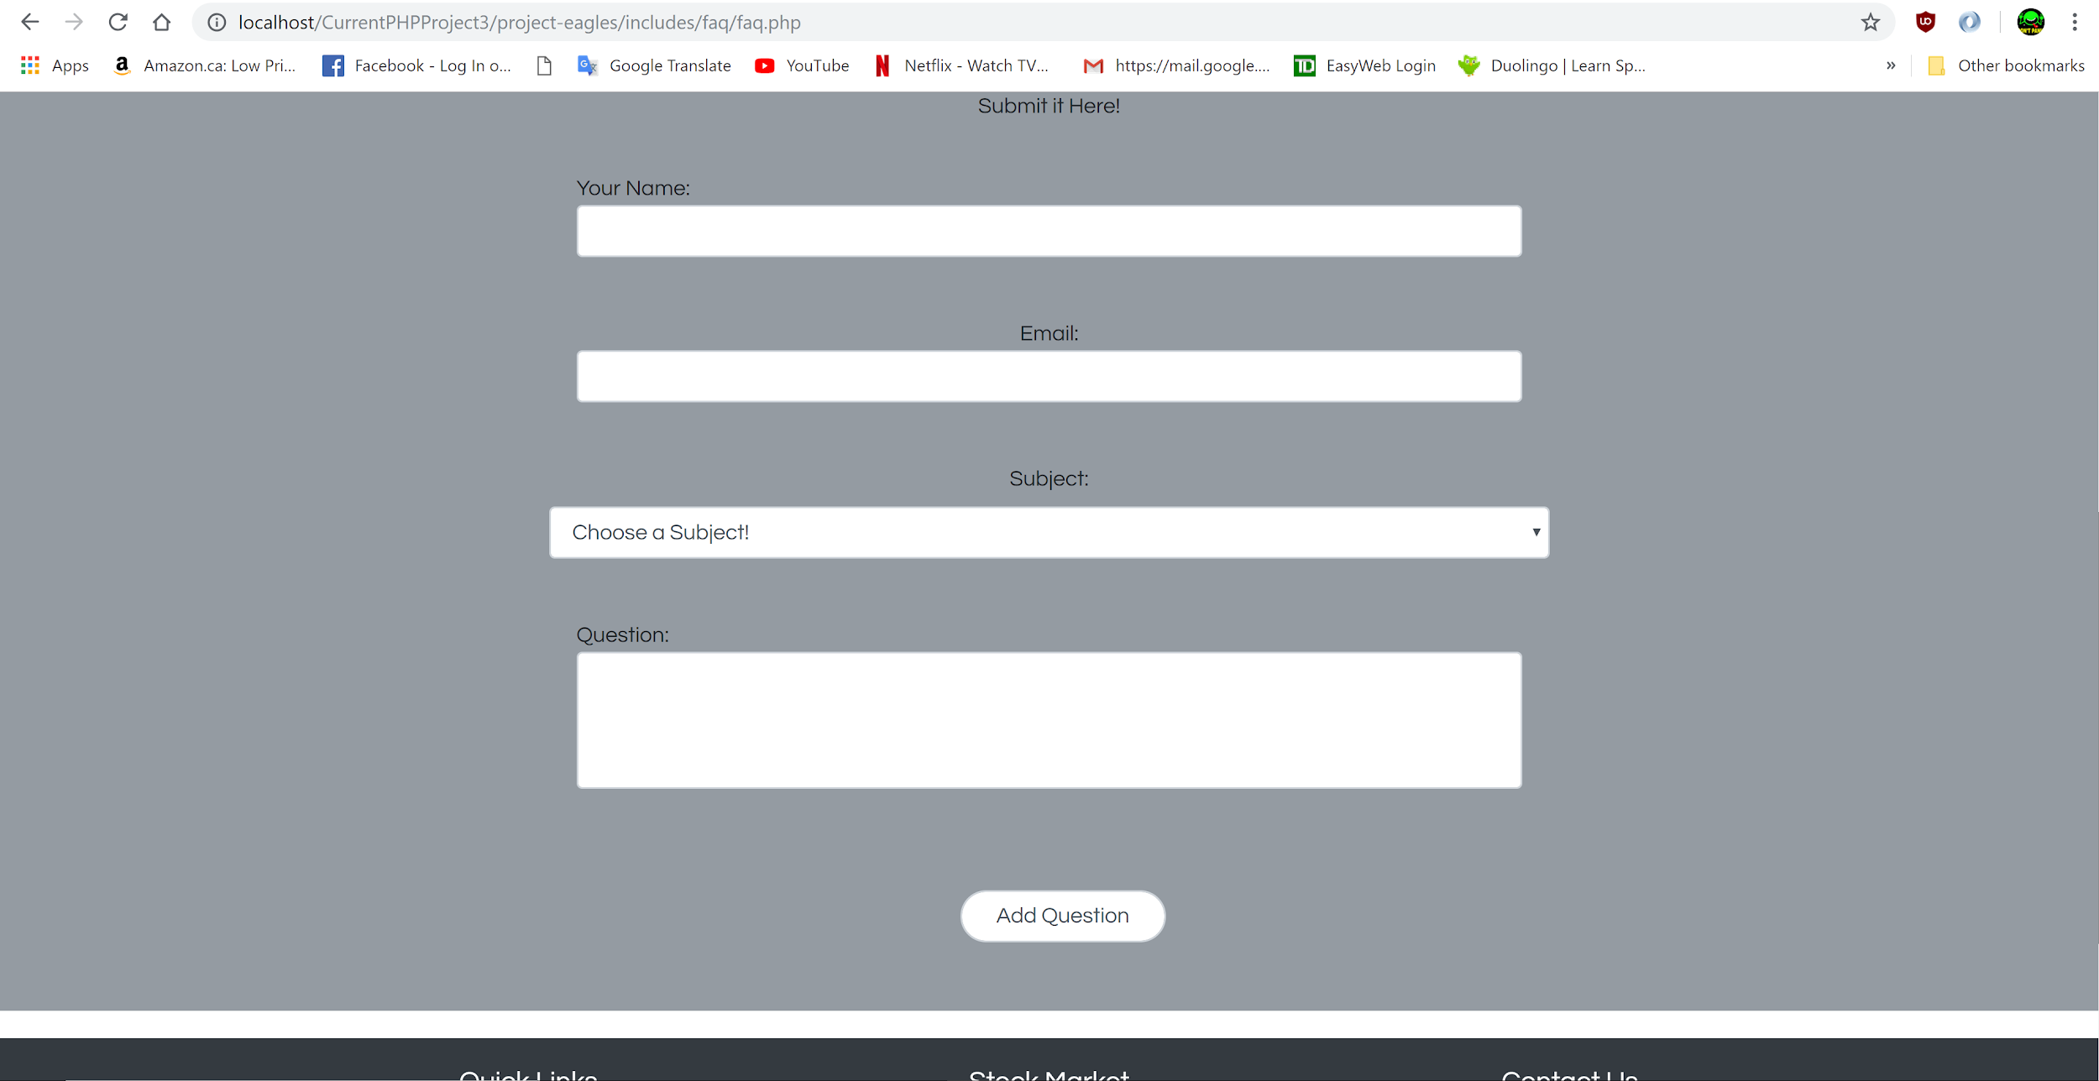

FAQ BOTTOM

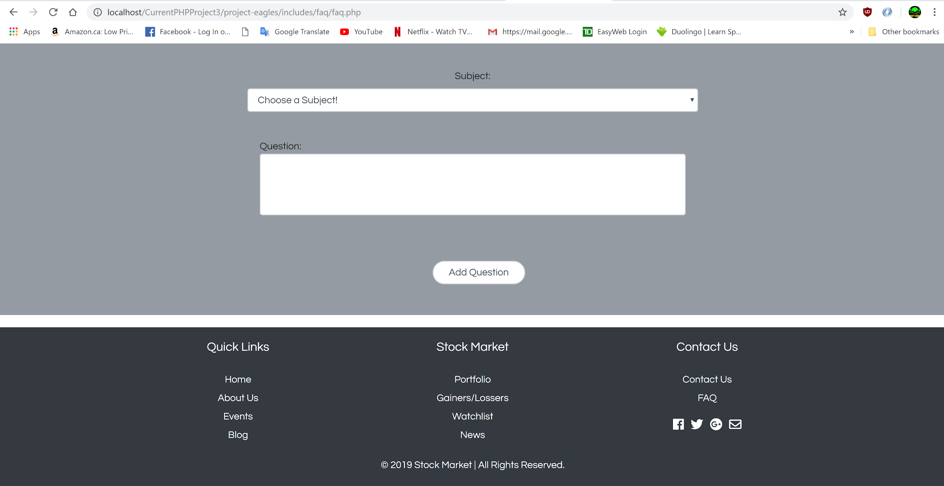

**CONTACT US PAGE:**

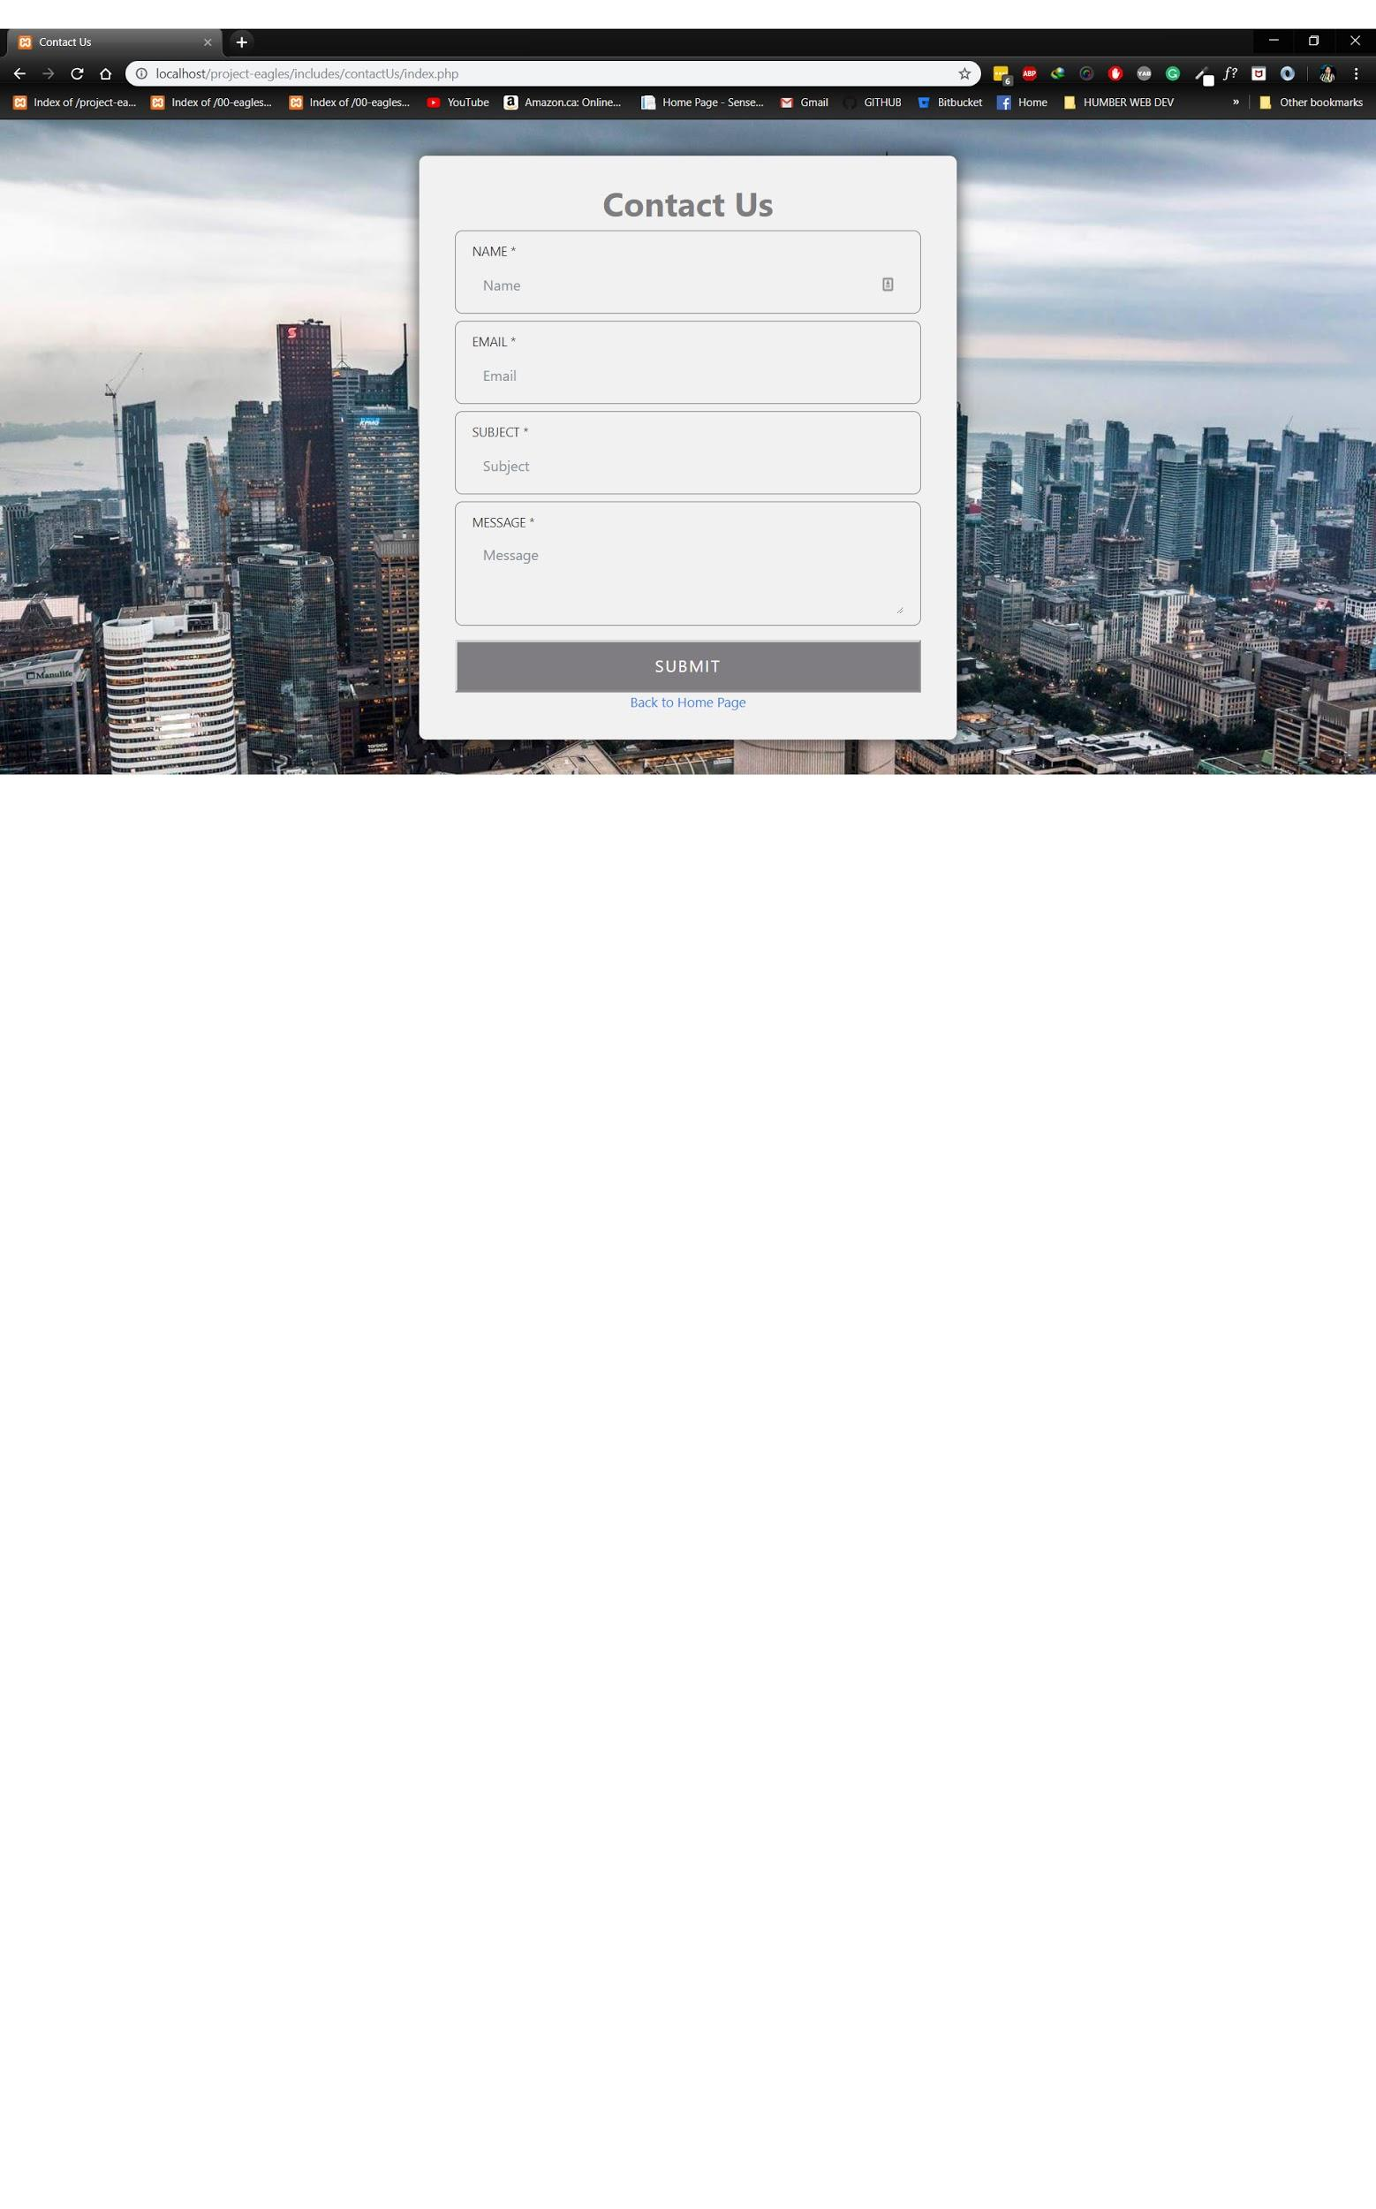

Contact Us admin page

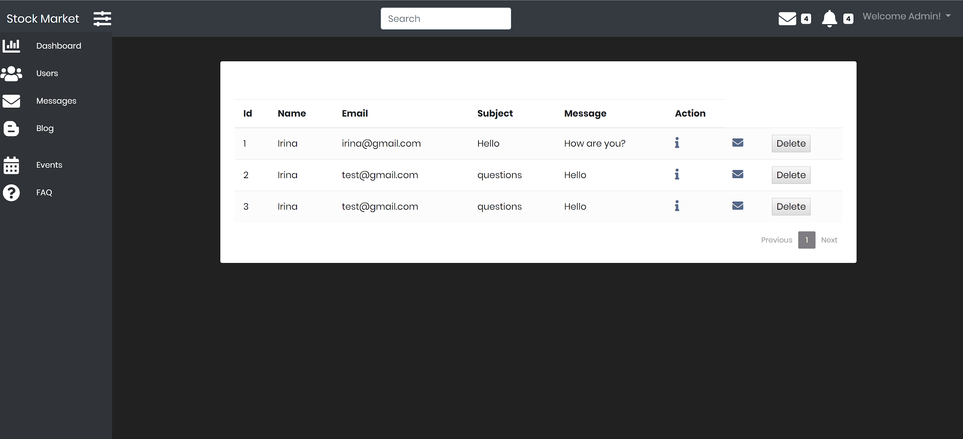

Details

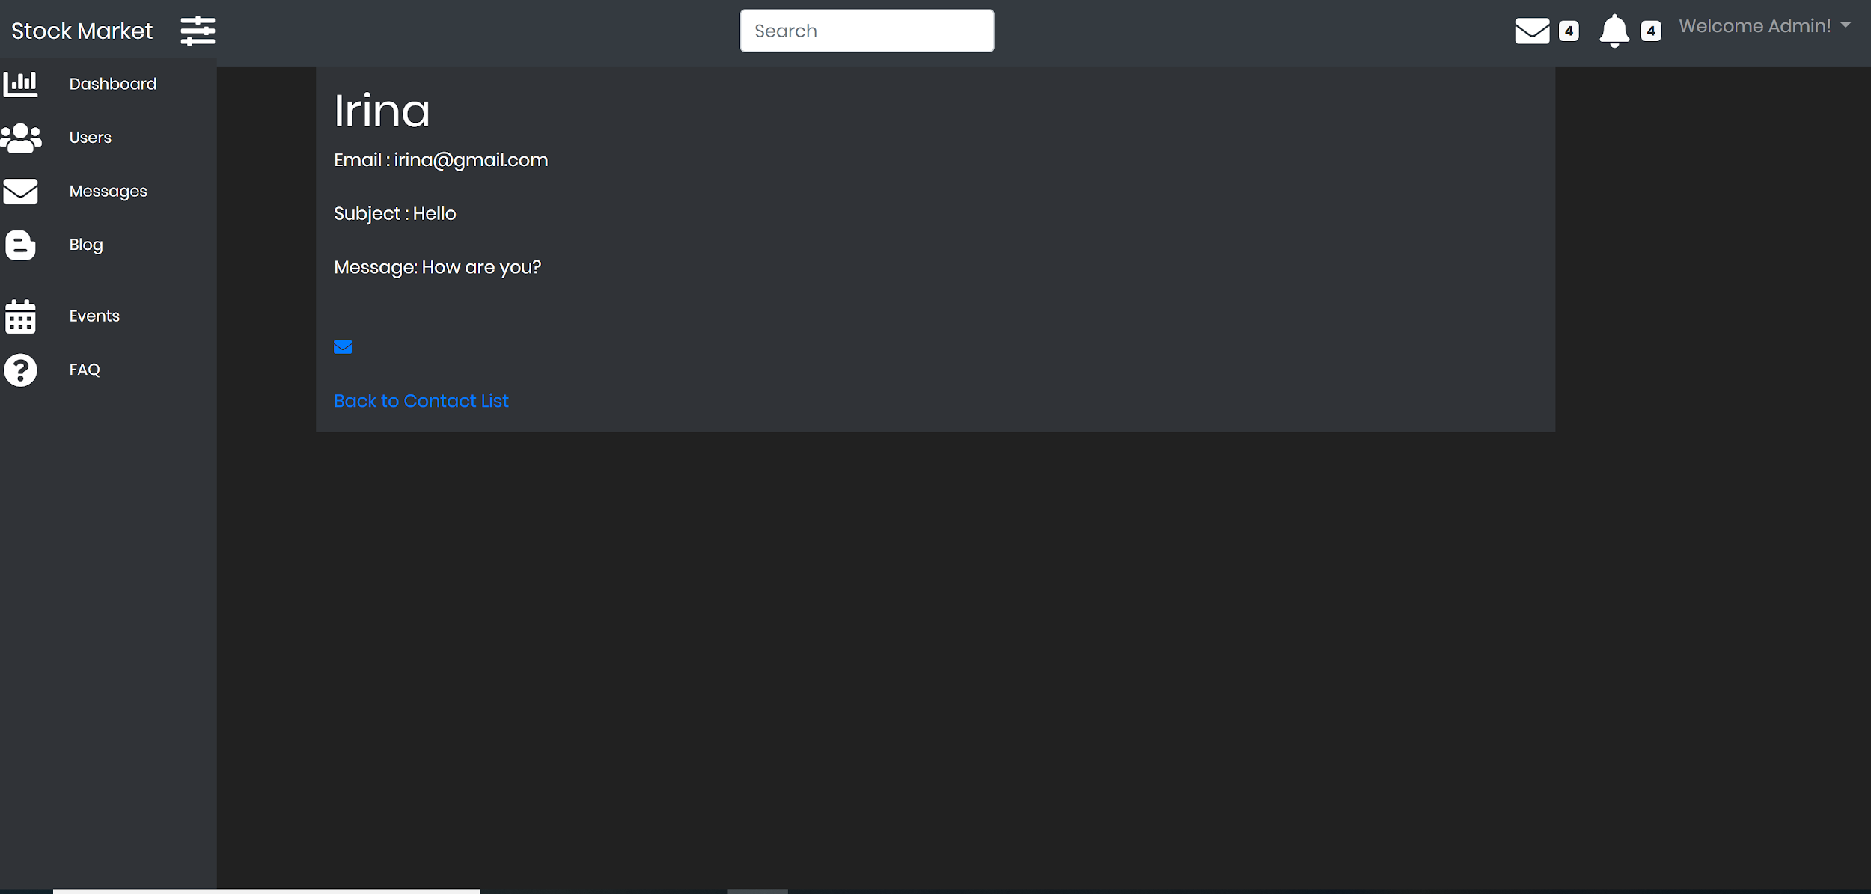

**IPO Calendar**

